

FEDERAL UNIVERSITY OF AGRICULTURE, ABEOKUTA
(FUNAAB)
COLLEGE OF ENGINEERING
DEPARTMENT OF MECHATRONICS ENGINEERING

STUDENTS INDUSTRIAL WORK EXPERIENCE SCHEME (SIWES)
TECHNICAL REPORT

A report submitted in partial fulfilment of the requirements
of the Students Industrial Work Experience Scheme (SIWES)
for the award of Bachelor of Engineering (B.Eng.) in Mechatronics Engineering,
Federal University of Agriculture, Abeokuta.

BY
TOLUWADE ARATOLUWADA GLEANER
20232229


Industrial Training undertaken at:
SQI COLLEGE OF ICT
Oke-Ilewo, Abeokuta, Ogun State

Duration: June 15 – September 11, 2026 (12 Weeks)

September 2026

DEDICATION
This report is dedicated to the LORD JESUS, for grace, wisdom, and sustenance throughout the duration of this programme, and to my parents, for their unwavering love, sacrifice, and encouragement throughout my academic journey.

ACKNOWLEDGEMENT
I would like to express my sincere gratitude to God Almighty for the strength, wisdom, and good health granted to me throughout the duration of this Students Industrial Work Experience Scheme (SIWES) programme.
My profound appreciation goes to the management and staff of SQI College of ICT, Oke-Ilewo, Abeokuta, for granting me the opportunity to undertake my industrial training within their organization. I am particularly grateful to my supervisors and the entire technical team across the Software Engineering department, whose patient mentorship and willingness to share their expertise made this training a genuinely enriching experience.
I also wish to thank the Department of Mechatronics Engineering, Federal University of Agriculture, Abeokuta, and my SIWES Institution-Based Supervisor, Engr. Amoo, for their guidance, monitoring, and constructive feedback throughout the duration of the programme.
Finally, I extend my heartfelt gratitude to my family and friends for their constant encouragement, prayers, and support, which sustained me through the demanding but rewarding twelve weeks documented in this report.

ABSTRACT
This report documents the industrial training undertaken by the author as part of the Students Industrial Work Experience Scheme (SIWES), a mandatory component of the Bachelor of Engineering programme in Mechatronics Engineering at the Federal University of Agriculture, Abeokuta (FUNAAB). The twelve-week attachment was undertaken at SQI College of ICT, Oke-Ilewo, Abeokuta, an organization engaged in software development, computer-aided design, and renewable energy systems integration, and was structured around four principal areas of engineering exposure: software engineering, computer-aided design (CAD) and 3D modelling, solar photovoltaic (PV) systems and installation, and the design and development of an Internet of Things (IoT) hardware project named GridWatch.
The report is organized topically rather than strictly chronologically. It begins with an overview of the SIWES scheme, the host organization, and the scope of training undertaken, before proceeding through dedicated chapters covering software engineering fundamentals using JavaScript and Node.js, embedded systems programming in C++ for microcontroller platforms including the Arduino and ESP32, computer-aided design and parametric 3D modelling using Onshape, and the theory and practical execution of a residential solar installation. The report then presents a detailed account of the GridWatch project, a remote monitoring and control system developed for a 2.5kVA solar inverter installation, comprising an ESP32-based firmware layer communicating over Modbus RTU with an SRNE MPPT charge controller, an MQTT-based data pipeline, a Node.js backend deployed to cloud infrastructure, and a web-based dashboard providing real-time and historical visibility into system performance.
The report concludes with a discussion of the integration and testing activities that brought the various components of the training together, a summary of the technical and professional competencies acquired over the course of the attachment, the challenges encountered and how they were resolved, and recommendations for the SIWES scheme, the host organization, and future students. Overall, the industrial training provided a comprehensive, hands-on complement to the theoretical foundation established in the classroom, bridging software engineering, embedded systems, mechanical design, and renewable energy engineering within the broader context of Mechatronics practice.

TABLE OF CONTENTS
DEDICATION 1
ACKNOWLEDGEMENT 1
ABSTRACT 1
TABLE OF CONTENTS 1
CHAPTER ONE 1
1.1 Overview of the Students Industrial Work Experience Scheme (SIWES) 1
1.2 Overview of the Host Organization 1
1.3 Scope and Structure of the Training 1
CHAPTER TWO 1
2.1 Introduction to the Chapter 1
2.2 JavaScript Language Fundamentals 1
2.3 Deepening JavaScript: Arrays, Objects, and Modern ES6+ Features 1
2.4 Applied JavaScript: Node.js, Express, and REST API Development 1
2.5 Reflection on the Software Engineering Foundation 1
CHAPTER THREE 1
3.1 Introduction to the Chapter 1
3.2 C++ Syntax Fundamentals and Transition from JavaScript 1
3.3 Introduction to Microcontroller Platforms: Arduino and ESP32 1
3.4 GPIO Control and Digital/Analog Interfacing 1
3.5 Serial Communication Protocols: UART, I2C, and SPI 1
3.6 Reflection on the Embedded Systems Foundation 1
CHAPTER FOUR 1
4.1 Introduction to the Chapter 1
4.2 CAD Fundamentals: Sketching, Constraints, and Feature-Based Modelling 1
4.3 Transition to Onshape and Cloud-Based Parametric Modelling 1
4.4 Applied 3D Modelling: Enclosures and Mounting Assemblies 1
4.5 Challenges and Reflection 1
CHAPTER FIVE 1
5.1 Introduction to the Chapter 1
5.2 Fundamentals of Solar Photovoltaic Systems 1
5.3 Site Survey and Installation Planning 1
5.4 Mounting, Panel Installation, and Electrical Wiring 1
5.5 Charge Controller and Inverter Commissioning 1
5.6 System Testing, Challenges, and Handover 1
5.7 Reflection and Relevance to Subsequent Work 1
CHAPTER SIX 1
6.1 Introduction to the Chapter 1
6.2 Project Motivation and Requirements 1
6.3 System Architecture 1
6.4 Week Nine: Node.js Application Groundwork 1
6.5 Week Ten: ESP32 Firmware and Modbus RTU Communication 1
6.6 Week Eleven: Backend Integration, Cloud Connectivity, and the Web Dashboard 1
6.7 Challenges Encountered During the GridWatch Project 1
6.8 Reflection on the GridWatch Project 1
CHAPTER SEVEN 1
7.1 Introduction to the Chapter 1
7.2 End-to-End System Integration Testing 1
7.3 Documentation and Handover 1
7.4 Report Compilation 1
CHAPTER EIGHT 1
8.1 Summary of Skills and Knowledge Gained 1
8.2 Challenges Encountered 1
8.3 Recommendations 1
8.4 Concluding Remarks 1

CHAPTER ONE
INTRODUCTION

1.1 Overview of the Students Industrial Work Experience Scheme (SIWES)
The Students Industrial Work Experience Scheme (SIWES) is a skills development programme established by the Industrial Training Fund (ITF) of Nigeria to bridge the gap between the theoretical instruction students receive in tertiary institutions and the practical, applied competencies demanded by industry. Conceived in 1973 and formally implemented from 1974, the scheme was introduced in response to a recognized deficiency in the Nigerian educational system, wherein graduates of science, engineering, technology, and other applied disciplines often emerged from their institutions with sound theoretical knowledge but with comparatively little exposure to the tools, workflows, and problem-solving demands of real working environments. SIWES addresses this gap by requiring students in designated disciplines to undertake a structured period of industrial attachment, typically lasting between four and six months depending on the course of study, during which they are placed in relevant organizations to gain first-hand exposure to professional practice under the supervision of experienced personnel.
For students of Mechatronics Engineering at the Federal University of Agriculture, Abeokuta (FUNAAB), SIWES constitutes a mandatory and academically credited component of the degree programme, coordinated jointly by the university's SIWES unit, the ITF, and the host organization. The scheme is guided by a small number of well-defined objectives: to expose students to the machinery, equipment, tools, and professional work practices not ordinarily accessible within a university laboratory setting; to prepare students for the industrial work situations they are likely to encounter after graduation; to provide an avenue for students to apply the theoretical knowledge acquired in the classroom to real, often ambiguous, practical problems; and to strengthen the relationship between universities and industry, thereby making it easier for institutions to adjust their curricula in line with the evolving needs of the labour market. This report has been prepared in fulfilment of the documentation requirements of the scheme and constitutes a comprehensive technical account of the twelve weeks of industrial training undertaken by the author.
Within the specific context of Mechatronics Engineering, a discipline that sits deliberately at the intersection of mechanical engineering, electronics, control systems, and software, SIWES carries particular importance. Mechatronics as a field is defined less by any single technical skill than by the ability to synthesize competencies across traditionally separate engineering domains in order to design and build integrated systems. A university curriculum, however well designed, can only expose students to a finite subset of the tools and workflows relevant to this synthesis within the constraints of scheduled coursework. The twelve-week attachment documented in this report was structured precisely to widen that exposure, spanning software engineering, embedded systems programming, computer-aided design, and renewable energy systems integration, four domains that, taken together, are broadly representative of the kind of cross-disciplinary engineering practice that Mechatronics as a field aspires to prepare its graduates for.

1.2 Overview of the Host Organization
The industrial training documented in this report was undertaken at SQI College of ICT, located at Oke-Ilewo, Abeokuta, Ogun State, an organization engaged in a combination of information and communication technology training, software development, engineering design services, and renewable energy systems integration. Beyond its core training programmes, the organization maintains an active technical practice spanning custom software development, mechanical and product design, and solar power installation for residential and small commercial clients within Abeokuta and the wider Ogun State area, providing attachees such as the author with exposure to genuine, client-facing engineering work rather than purely instructional exercises.
The organization's operations during the period of the author's attachment were broadly organized around four functional units, each of which is reflected in the structure of this report. The Software Engineering unit was responsible for the design, development, and maintenance of web applications and backend services for both internal tooling and client-facing products, working primarily in JavaScript across the Node.js runtime and associated frameworks such as Express. The CAD and Design unit handled mechanical and product design work, making use of parametric, cloud-based computer-aided design tools, principally Onshape, to produce components, enclosures, and mounting assemblies for both internal hardware projects and client deliverables. The Solar Installation unit was responsible for the design, sizing, installation, and commissioning of residential and small-scale commercial solar photovoltaic systems, ranging from initial site surveys through to system handover and after-installation support. Finally, an internal hardware and IoT development effort, centred on the GridWatch project described in detail in Chapter Six of this report, brought together embedded systems engineering, cloud infrastructure, and web development in pursuit of a remote solar system monitoring solution intended to complement the organization's solar installation business.

Plate 1.1: The author on-site at SQI College of ICT, Oke-Ilewo, Abeokuta.

1.3 Scope and Structure of the Training
The author's industrial training spanned a period of twelve weeks, during which exposure was structured across the four functional areas of the host organization described above, in a sequence designed to build technical competency progressively, beginning with foundational software engineering skills and culminating in the design, development, and testing of an integrated hardware and software project. Rather than being confined to a single department for the full duration of the attachment, the author rotated through each of the organization's units in turn, a structure that, while occasionally demanding in terms of the range of technical material to be absorbed within a limited timeframe, proved highly effective in exposing the author to the breadth of engineering practice that a Mechatronics graduate is expected to be conversant with.
The training began with an intensive introduction to JavaScript programming, progressing over the first three weeks from fundamental language syntax through more advanced concepts including arrays, objects, and modern ECMAScript (ES6+) features, before culminating in applied backend development using Node.js, the Express framework, and the design of RESTful application programming interfaces (APIs). This software engineering foundation is documented in Chapter Two of this report. The fourth week shifted focus to embedded systems, covering C++ programming fundamentals and their application to microcontroller platforms, specifically the Arduino and ESP32, including general-purpose input/output (GPIO) control and serial communication protocols such as UART, I2C, and SPI; this material is presented in Chapter Three.
The subsequent weeks introduced computer-aided design, beginning with foundational CAD principles and progressing to parametric 3D modelling using the cloud-based platform Onshape, documented in Chapter Four. This was followed by an introduction to solar energy systems, covering the theoretical fundamentals of photovoltaic system design and sizing, and culminating in direct participation in a residential solar installation practicum, both of which are presented together in Chapter Five given their close thematic relationship. The final and most substantial portion of the training, spanning three weeks and documented in Chapter Six, was devoted to the GridWatch project, an Internet of Things (IoT) monitoring and control system developed for a 2.5kVA solar inverter installation, encompassing embedded firmware development, cloud connectivity via the MQTT protocol, backend service development, and the design of a real-time web dashboard. The training concluded with a period of system integration, testing, and report compilation, documented in Chapter Seven, during which the various strands of the twelve-week programme were consolidated into a working, tested system and into the present report.
This report has accordingly been organized thematically by area of technical focus rather than strictly by calendar week, in order to present each domain of the training as a coherent, self-contained body of work while still preserving the chronological narrative of how the author's skills and responsibilities developed over the course of the twelve-week attachment. It is hoped that this structure allows the reader to appreciate both the depth of engagement within each technical area and the manner in which the various strands of the training converged, by the final weeks, into the integrated GridWatch project that serves as the centrepiece of this account.

CHAPTER TWO
SOFTWARE ENGINEERING FUNDAMENTALS: JAVASCRIPT

2.1 Introduction to the Chapter
The first three weeks of my industrial training were devoted almost entirely to software engineering, and specifically to the JavaScript programming language and its surrounding ecosystem. This choice of starting point was, I came to understand, deliberate on the part of the organization: JavaScript's relatively gentle initial learning curve, combined with its immediate visual and interactive feedback in a browser environment, made it an efficient vehicle for assessing and building general programming competency before I was introduced to the comparatively less forgiving world of embedded C++ in Week Four. Over the course of these three weeks, my instruction progressed along a clear trajectory: from core language syntax and control flow in the first week, through a deeper treatment of arrays, objects, and modern ECMAScript (ES6+) features in the second week, to applied, backend-oriented development using Node.js, the Express framework, and the design of RESTful APIs in the third. This chapter presents that progression as a single coherent narrative, organized by topic rather than strictly by week, since the boundaries between the three weeks were, in practice, less rigid than the training schedule suggested; concepts introduced in the first week were revisited and deepened throughout, and by the third week I was routinely drawing on everything that had come before it.
Beyond the specific syntax and APIs I learned, this chapter also documents a broader shift in how I approached programming problems generally. Prior to this attachment, my exposure to programming had come almost entirely through university coursework in C and MATLAB, both of which are taught with a heavy emphasis on procedural, single-file, numerically oriented problem solving. JavaScript, by contrast, exposed me to an ecosystem built around asynchronous execution, modular file organization, package management, and a culture of building applications by composing small, well-tested pieces of functionality, and adapting to this different way of thinking about software turned out to be as significant a part of the learning curve as the language syntax itself.

2.2 JavaScript Language Fundamentals
My first days on the software engineering team were spent under the guidance of a mentor assigned specifically to bring new attachees up to speed on the organization's primary technology stack, and JavaScript was the natural starting point given its centrality to nearly every product the Software Engineering unit maintained. I began with the absolute fundamentals: variable declaration using var, let, and const, and a discussion of why the organization's internal style guide strongly discouraged the use of var in favour of the block-scoped let and const, owing to the well-documented pitfalls of var's function-level scoping and its tendency to produce subtle bugs in loops and conditional blocks. This distinction, which had seemed like a minor stylistic preference when I first read about it, became considerably more concrete once my mentor walked me through a short exercise demonstrating how a var-declared loop counter could leak unexpected values into a closure, a class of bug I later learned to watch for instinctively.
From variable declaration, I progressed to JavaScript's primitive data types (strings, numbers, booleans, null, undefined, and symbols), its dynamic and loosely typed nature, and the type coercion rules that govern how the language behaves when values of different types are compared or combined, a topic my mentor treated with particular seriousness given how often subtle coercion bugs arise in production code from comparisons using the loose equality operator rather than its strict counterpart. I practised writing conditional logic using if-else chains, switch statements, and the ternary operator, and worked through a series of small exercises involving loops, including for, while, and do-while constructs, applied to simple numerical and string-processing problems reminiscent of the kind of exercises I had encountered in earlier programming coursework, but now expressed in JavaScript's particular syntax and idioms.
Functions occupied a substantial portion of the early instruction, beginning with traditional function declarations and function expressions, and proceeding to arrow function syntax, which I was encouraged to adopt as the organization's preferred style for most callback and utility functions owing to its concise syntax and its lexical binding of the this keyword, a behaviour that traditional function expressions do not share and which my mentor illustrated with an example involving a mishandled this reference inside a settimeout callback nested within an object method. I also spent time on the concept of function scope and closures, writing small exercises such as counter-generating functions and simple memoization utilities to build an intuitive feel for how JavaScript functions retain access to variables from their enclosing lexical scope even after that scope has technically finished executing. This concept of closures, more than perhaps any other single topic in the first week, required repeated exposure and several false starts before it genuinely clicked, but once it did, it substantially improved my ability to reason about the asynchronous code I would encounter later in the training.
The first week also introduced me to the browser's Document Object Model (DOM) and to JavaScript's role as the language of interactivity on the web, since a portion of the organization's early exercises were built around simple browser-based tasks: selecting and manipulating DOM elements, attaching event listeners to buttons and form inputs, and dynamically updating page content in response to user interaction. While the organization's actual production work leaned much more heavily toward backend and API development, this early browser-focused instruction gave me a useful mental model of the full request-response and user-interaction cycle that a web application sits within, a model that proved helpful context even once my later work shifted almost entirely toward server-side JavaScript.

2.3 Deepening JavaScript: Arrays, Objects, and Modern ES6+ Features
The second week built directly on this foundation, with a much closer focus on JavaScript's two most important composite data structures: arrays and objects. I had, of course, used arrays and objects informally during the first week's exercises, but the second week formalized my understanding of them and, more importantly, introduced me to the rich set of built-in array methods that idiomatic JavaScript code relies on extensively. I spent considerable time working through exercises using map, filter, and reduce, three methods that my mentor described, only half-jokingly, as forming the backbone of most real-world JavaScript data manipulation. I recall one exercise in particular that required me to take a raw array of sample sensor readings, filter out invalid or out-of-range values, map the remaining values into a normalized unit, and then reduce the result to a summary statistic such as an average; this single exercise, though simple in isolation, foreshadowed almost exactly the kind of data-processing logic I would later write for the GridWatch backend when handling batches of telemetry readings from the ESP32 firmware.
Alongside these array methods, I studied array destructuring, the spread and rest operators, and methods such as find, some, every, includes, and the various array sorting and searching utilities, gradually replacing my initial instinct to reach for manually written for loops with a preference for these more declarative, expression-oriented alternatives wherever they improved readability. My mentor was careful to note that this was a matter of style and clarity rather than an absolute rule, since there remain cases, particularly performance-sensitive ones, where a traditional loop is the more appropriate choice, but the general encouragement was toward the more idiomatic functional style that dominates the organization's codebase.
Objects received similarly close attention. I practised object literal syntax, property shorthand, computed property names, and object destructuring, including nested destructuring patterns used to extract specific fields from more deeply structured data, a pattern I would go on to use extensively when parsing JSON payloads in the Express APIs I built in the third week and, later, when parsing MQTT message payloads in the GridWatch backend. I also studied the distinction between shallow and deep copying of objects and arrays, a subtlety that JavaScript does not handle automatically and that caused me some early confusion when a function I had written appeared to be unexpectedly mutating data it should only have been reading; my mentor used this exact bug, which I had produced myself without initially realizing it, as a teaching moment about reference versus value semantics in JavaScript, a distinction that I subsequently made a conscious habit of checking for whenever I passed objects or arrays between functions.
The second week also introduced a cluster of modern ECMAScript (ES6 and later) features that, taken together, substantially changed the character of the code I was writing compared to the more traditional syntax I had started with in Week One. Template literals replaced string concatenation for constructing dynamic strings, the class syntax provided a cleaner, more familiar way of expressing object-oriented patterns compared to JavaScript's underlying prototype-based inheritance model, and default parameters, optional chaining, and the nullish coalescing operator all featured in exercises designed to demonstrate how contemporary JavaScript code handles missing or optional data more gracefully than older idioms involving repeated manual checks for undefined or null. I also received my first proper introduction to JavaScript's module system, learning to organize code across multiple files using import and export statements rather than relying on a single monolithic script, a shift in code organization that anticipated the multi-file project structures I would work within for the remainder of the training, including the GridWatch backend.
Perhaps the most consequential topic introduced during the second week, however, was asynchronous programming. My mentor introduced the event loop conceptually first, using diagrams and analogies to explain why JavaScript, despite being fundamentally single-threaded, is nonetheless able to handle operations such as network requests or file reads without blocking the execution of other code. From this conceptual foundation, I progressed through callbacks, then Promises, and finally the async/await syntax that has become the dominant idiom for asynchronous JavaScript code in recent years. I wrote exercises simulating delayed operations using setTimeout wrapped in Promises, chained multiple asynchronous operations together, and practised proper error handling using try-catch blocks around await expressions as well as .catch handlers on raw Promise chains. This material, more than any other topic in the first two weeks, would prove to be directly and repeatedly useful throughout the rest of my training, since essentially all meaningful interaction with external systems in JavaScript, whether an HTTP request to an API, a database query, or, much later, a message published to an MQTT broker, is asynchronous in nature.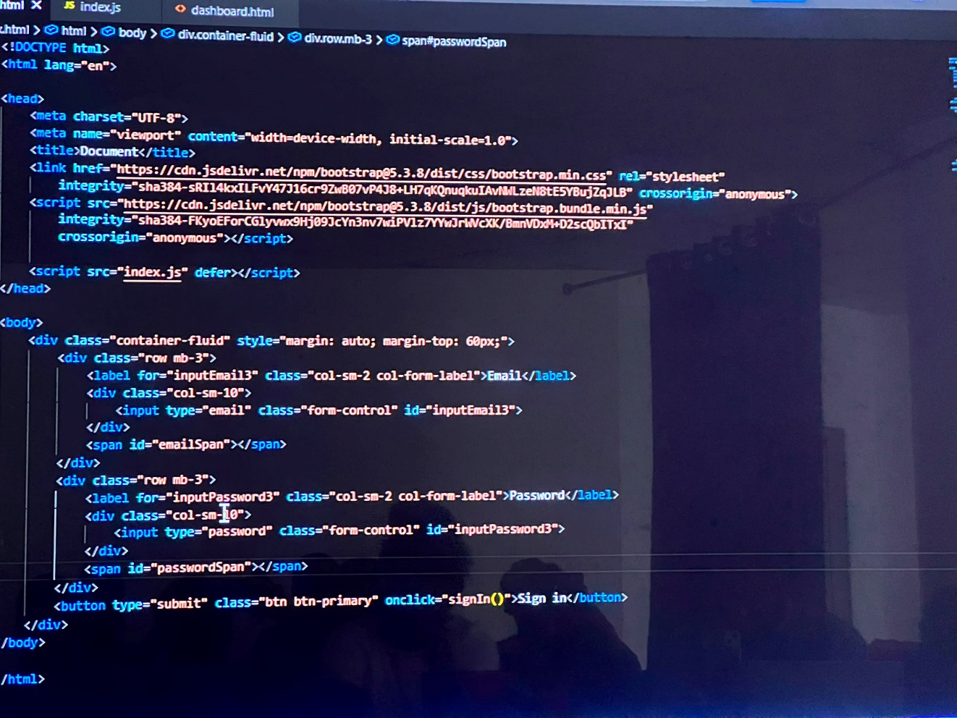

2.4 Applied JavaScript: Node.js, Express, and REST API Development
The third week shifted the focus of my training from the JavaScript language itself to its application in a server-side context, using the Node.js runtime. I was first introduced to Node.js conceptually, as a runtime environment that executes JavaScript outside the browser using the same underlying V8 engine that powers Google Chrome, and my mentor took some care to explain how this had, since Node's introduction, allowed JavaScript to become a genuinely full-stack language, used on both the client and server sides of a web application, a unification that partly explained the organization's own preference for a JavaScript-centric technology stack across its software projects. I practised using the Node.js runtime from the command line, running simple scripts, and became familiar with Node's built-in module system and a handful of its core modules, including the file system (fs) module for reading and writing files and the path module for handling file system paths in a platform-independent way.
A significant part of the third week was devoted to the Node Package Manager (npm) and the broader package ecosystem it provides access to. I learned to initialize a new Node.js project using npm init, to install both regular and development dependencies, to interpret the resulting package.json and package-lock.json files, and to understand the semantic versioning conventions that govern how package version numbers communicate the nature of changes between releases. This exposure to dependency management was, in its own way, as important a lesson as any specific API, since nearly every subsequent piece of software I built during the remainder of my training, including the GridWatch backend, depended on a curated set of third-party packages rather than being written entirely from first principles, and understanding how to responsibly select, install, and manage these dependencies was an essential practical skill.
With this foundation in place, I was introduced to Express, a minimal and widely used web application framework for Node.js, which the organization used as the backbone of nearly all of its backend services. I built a series of progressively more complex exercises using Express, beginning with a simple server that responded to basic HTTP GET requests, and gradually expanding this to handle multiple HTTP methods (GET, POST, PUT, DELETE), route parameters, query strings, and request bodies parsed as JSON using Express's built-in middleware. The concept of middleware itself required some deliberate study, since it represented a somewhat different way of structuring request-handling logic than anything I had encountered previously; I came to understand middleware functions as composable units that each inspect or modify a request and response before passing control to the next function in the chain, a pattern I practised by writing simple logging middleware, basic input validation middleware, and rudimentary error-handling middleware placed at the end of the middleware chain to catch and format errors consistently across the application.
The culminating exercise of the third week, and in many respects of the entire JavaScript-focused portion of my training, was the design and implementation of a small RESTful API from scratch, modelled on a simplified inventory management use case suggested by my mentor. I designed the API's resource structure and route naming conventions in line with REST principles, using plural nouns for resource collections, appropriate HTTP methods to signal the intent of each operation, and consistent JSON response structures including proper HTTP status codes for success and error conditions. The exercise required implementing full create, read, update, and delete (CRUD) functionality for a single resource type, initially backed by an in-memory JavaScript array standing in for a database, with data validated on input and appropriate error responses returned for malformed requests or requests referencing non-existent resources. I tested the resulting API using a combination of a command-line HTTP client and a graphical API testing tool, sending requests manually to verify that each endpoint behaved as specified before my mentor reviewed the implementation and offered feedback, most notably on tightening my input validation logic and on restructuring several route handlers to reduce duplicated logic by extracting shared functionality into separate utility functions.
This third week's work in Express and REST API design turned out to be the most directly transferable skill from the entire JavaScript chapter of my training, since the architecture I designed and built for this exercise, a Node.js and Express backend exposing a RESTful API over JSON, is structurally almost identical to the backend I would go on to build for the GridWatch project in Week Ten, differing mainly in the nature of the data being served, telemetry from a solar monitoring device rather than inventory records, and in the addition of a WebSocket layer for real-time updates and an MQTT client for ingesting data from the field. Having built a smaller, self-contained version of this architecture during Week Three meant that when I returned to very similar problems six weeks later in the context of GridWatch, I was extending and adapting a pattern I already understood, rather than learning it for the first time under the added pressure of a live hardware project.

2.5 Reflection on the Software Engineering Foundation
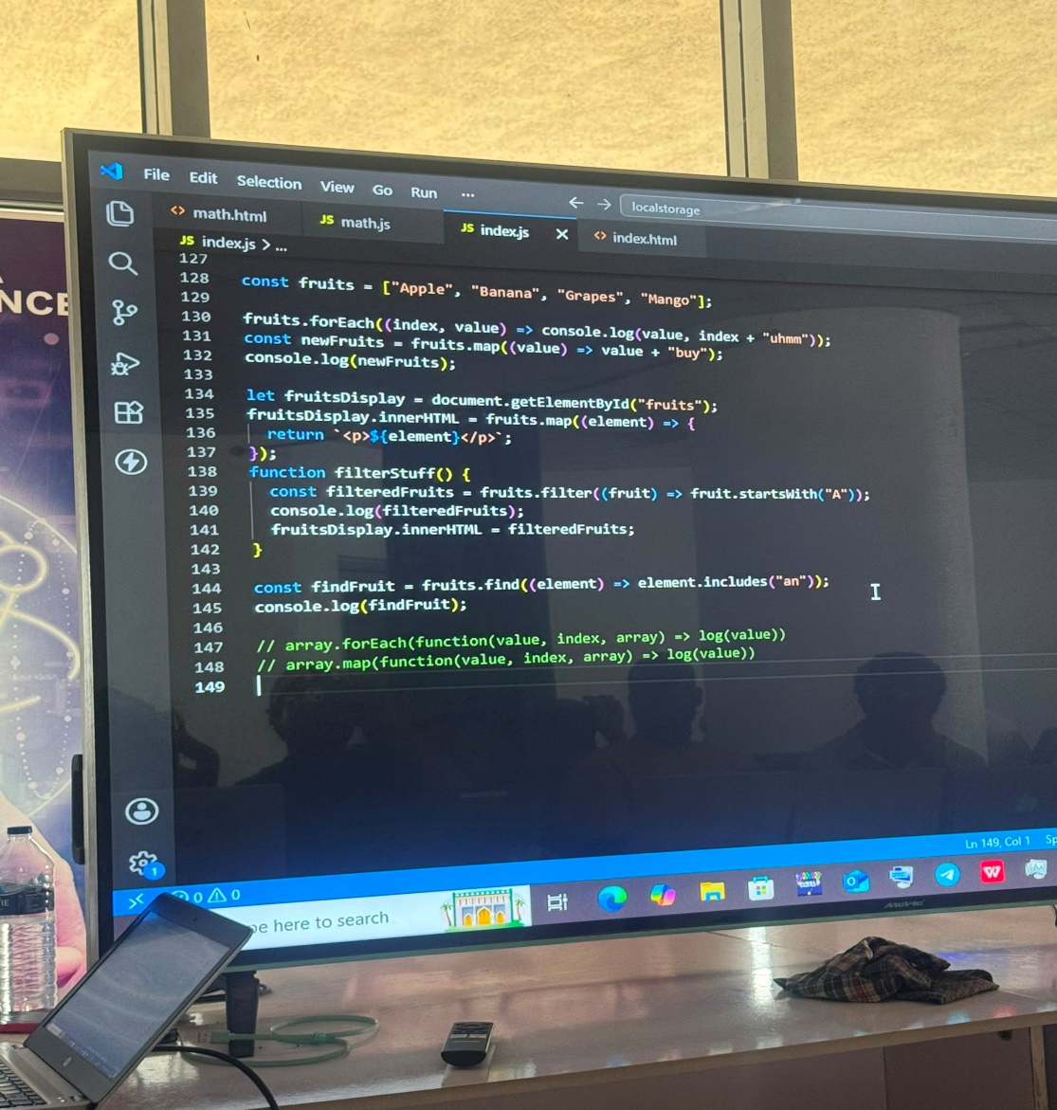
Looking back on these first three weeks, I recognize them as having established not just a specific set of JavaScript skills but a general working method that shaped how I approached every subsequent technical challenge during my training. The emphasis on breaking problems into small, testable pieces, on reading documentation and error messages carefully rather than guessing at fixes, and on maintaining a disciplined, modular code structure even in small exercises, were habits instilled during this period that proved just as relevant when I later moved into embedded C++ programming, CAD modelling, and ultimately the GridWatch project. If the twelve weeks of my SIWES attachment are understood as a single continuous arc, these first three weeks functioned as its foundation, both in the literal sense of the specific tools and APIs I learned, and in the more general sense of the disciplined, incremental approach to building software that I carried forward into every subsequent chapter of this report.

CHAPTER THREE
EMBEDDED SYSTEMS: C++ AND MICROCONTROLLER PROGRAMMING

3.1 Introduction to the Chapter
The fourth week of my industrial training marked a deliberate and fairly abrupt shift in register from the high-level, browser- and server-oriented JavaScript work of the preceding three weeks to the comparatively low-level, resource-constrained world of embedded systems programming in C++. Where JavaScript had offered a forgiving runtime, automatic memory management, and an interactive development experience, embedded C++ development on microcontroller platforms offered none of these conveniences, and the transition required me to think much more deliberately about memory, timing, and the physical hardware my code was ultimately controlling. This chapter documents that week of training, covering the progression from core C++ syntax review through microcontroller-specific programming concepts on the Arduino and ESP32 platforms, general-purpose input/output (GPIO) control, and serial communication protocols including UART, I2C, and SPI.
This week carried a significance beyond its own content, since it represented the point at which my training began, however implicitly, to prepare me for the GridWatch project that would occupy the final quarter of my attachment. Although I did not yet know the specific shape that GridWatch would take when I was introduced to embedded C++ programming in Week Four, the organization's training structure was evidently designed with this eventual project in mind, and nearly every concept covered during this week, from basic GPIO digital output to the intricacies of serial communication protocols, reappeared in direct, practical form when I came to design the ESP32-based firmware for GridWatch in Week Ten. This chapter should accordingly be read as documenting not only the acquisition of embedded systems fundamentals in their own right, but the deliberate laying of technical groundwork for the hardware-software integration project that followed.

3.2 C++ Syntax Fundamentals and Transition from JavaScript
My introduction to this week's material began, somewhat unusually, not with hardware at all but with a review of core C++ syntax, since although I had encountered C during earlier university coursework, my most recent and fluent programming experience by this point was in JavaScript, and my mentor for this portion of the training, a different member of staff from the one who had guided my JavaScript instruction, was keen to ensure I was comfortable with C++'s statically typed, compiled nature before introducing any hardware-specific complexity. This review covered variable declaration with explicit type annotations, the primitive data types available in C++ (int, float, double, char, bool, and their various sized and unsigned variants), and the way the language's static typing requires the programmer to commit to a variable's type and, implicitly, its memory footprint, at the point of declaration, a marked contrast to the dynamic, loosely typed variables I had grown accustomed to in JavaScript over the preceding three weeks.
I practised writing functions with explicit return types and typed parameters, and revisited control flow constructs, if-else statements, switch-case blocks, and for, while, and do-while loops, all of which were syntactically similar to their JavaScript counterparts but which now operated within a stricter type system that caught certain classes of error at compile time rather than allowing them to surface only at runtime. My mentor was particular about the discipline this stricter type system demands, noting that in an embedded context, where a firmware bug might not simply throw a console error but could cause a physical actuator to misbehave or a sensor reading to be silently corrupted, the additional rigour that C++'s compiler enforces is a genuine asset rather than an inconvenience.
A substantial part of this early review was devoted to pointers and references, concepts that have no direct equivalent in JavaScript and that consequently required the most deliberate, patient instruction of anything covered in this opening section. I worked through exercises declaring pointer variables, dereferencing them to access the value at a given memory address, and using the address-of operator to obtain the address of an existing variable, building up gradually from simple examples to slightly more involved ones involving pointers to arrays and pointers passed as function parameters to allow a function to modify a caller's variable directly, a pattern I learned to recognize as broadly analogous to, though implemented quite differently from, the reference semantics of objects and arrays I had studied in JavaScript during Week Two. I also studied the distinction between stack and heap memory allocation, the use of the new and delete operators for dynamic memory management, and, importantly, the discipline required to avoid memory leaks by ensuring every dynamically allocated block of memory is eventually released, a category of responsibility that JavaScript's garbage collector had entirely hidden from me until this point. My mentor was careful to note that on microcontroller platforms with only a few hundred kilobytes of RAM, of the kind I would shortly be working with, careless dynamic memory allocation is a particularly common source of instability, and that idiomatic embedded C++ code tends to favour statically allocated, fixed-size buffers wherever possible rather than the more liberal dynamic allocation patterns common in desktop or server-side C++ applications.
Finally, this opening section introduced or revisited structs and classes, C++'s object-oriented programming features including constructors, member functions, and access specifiers, and basic use of the C++ Standard Library, though with the caveat, which became more significant once I moved to the Arduino and ESP32 platforms, that embedded development frequently avoids large portions of the standard library in favour of leaner, platform-specific alternatives better suited to constrained memory environments.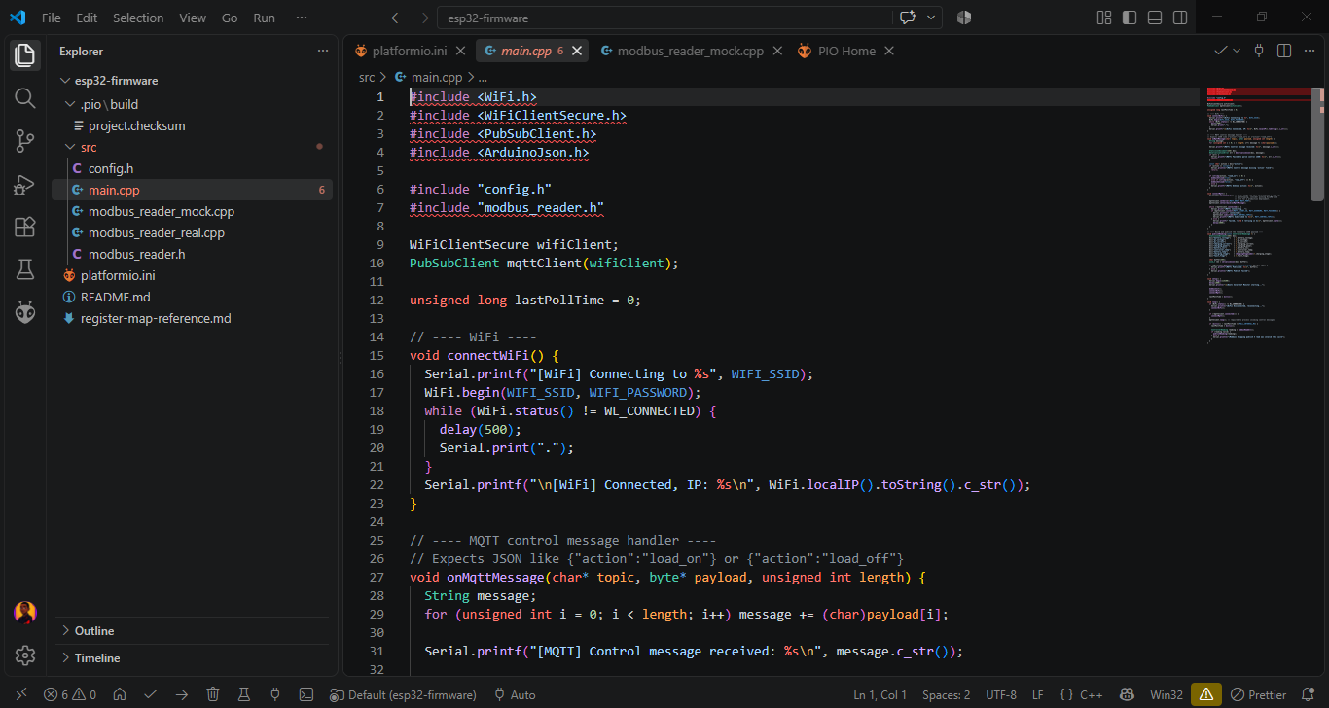

3.3 Introduction to Microcontroller Platforms: Arduino and ESP32
With this syntax foundation in place, the remainder of the week shifted to hands-on microcontroller programming, beginning with the Arduino platform before progressing to the more capable ESP32. My mentor introduced the Arduino Integrated Development Environment (IDE) and the general structure of an Arduino sketch, explaining the two mandatory functions, setup, which runs once at power-on or reset and is used for initialization tasks, and loop, which runs repeatedly for as long as the device remains powered, a structure I found conceptually reminiscent of an event loop but implemented as a simple, continuously polling superloop rather than the callback-driven asynchronous model I had grown used to in Node.js. I was introduced to the specific Arduino board used for this training, and spent time simply examining its physical layout: the digital and analog pins, the onboard voltage regulator, the USB-to-serial interface used for programming and debugging, and the power input options.
My first practical exercises involved the canonical starting point for embedded development, blinking an onboard or externally wired LED at a fixed interval using digitalWrite calls and the delay function, an exercise that felt almost comically simple in isolation but that usefully forced me to work through the entire toolchain, writing code in the IDE, compiling it, uploading it to the physical board over USB, and observing the result in the physical world, for the first time. From this starting point, I progressed to reading digital input from a pushbutton, using both simple polling logic and, once introduced to the concept, a brief discussion of hardware interrupts as a more efficient alternative to constantly polling a pin in the main loop for state changes. I then moved to analog input, reading a variable voltage from a potentiometer using the analogRead function and mapping the resulting raw reading to a more meaningful output range using the map function, and analog-adjacent output using pulse-width modulation (PWM) to control the brightness of an LED or, in a later exercise, the speed of a small DC motor, a technique I understood conceptually from earlier coursework but had not previously implemented in code.
Having established these fundamentals on the Arduino platform, my mentor introduced the ESP32, a considerably more capable microcontroller that would go on to serve as the central processing platform for the GridWatch project. I learned that the ESP32, unlike the more basic Arduino boards I had just worked with, integrates a dual-core processor, considerably more RAM and flash storage, and, critically, built-in WiFi and Bluetooth connectivity, making it a natural choice for Internet of Things applications that need to communicate with cloud services rather than operating in isolation. I set up the Arduino IDE's board support for the ESP32 and worked through several exercises adapting the GPIO and PWM code I had just written for the Arduino to run on the ESP32 instead, noting along the way several practical differences between the platforms, including the ESP32's use of a different analog-to-digital converter with its own resolution and reference voltage characteristics, and its GPIO pin numbering scheme, which does not correspond directly to the pin layout conventions I had just become accustomed to on the Arduino. This exercise in porting code between two related but non-identical microcontroller platforms proved to be a valuable lesson in the general discipline of embedded development, where, unlike in the more standardized world of server-side JavaScript I had worked in during the previous three weeks, hardware-specific quirks and datasheet details cannot be abstracted away and must be handled explicitly in code.

3.4 GPIO Control and Digital/Analog Interfacing
Building on these initial exercises, I spent a further portion of the week deepening my understanding of general-purpose input/output (GPIO) programming, since GPIO pins are the fundamental interface through which a microcontroller senses and acts upon its physical environment, and a solid grasp of GPIO behaviour underpins essentially all embedded development, including the sensor and control logic I would later write for GridWatch. I practised configuring pins in input, output, and, on the ESP32, input-pullup and input-pulldown modes, and discussed with my mentor the practical reasoning behind using internal pull-up or pull-down resistors when reading from simple switches, avoiding the floating-pin behaviour that can otherwise produce erratic, noise-driven readings on an unconnected digital input.
I built a series of small circuits on a breadboard to accompany these exercises, wiring pushbuttons, LEDs, and a simple piezo buzzer to the ESP32's GPIO pins, and writing corresponding code to read inputs and drive outputs in combination, for instance illuminating an LED and sounding a brief tone when a button was pressed, and introducing simple debounce logic in software to filter out the rapid, spurious signal transitions that mechanical switches are prone to producing during the brief physical settling period after being pressed or released. I also worked through an exercise involving an analog temperature sensor, reading a raw analog voltage from the sensor, converting that raw ADC reading into a calibrated temperature value using the sensor's documented voltage-to-temperature relationship, and printing the resulting value to the serial monitor at a regular interval, an exercise that, again, anticipated in miniature the kind of sensor-reading and value-conversion logic I would later need to write when parsing register values read from the SRNE charge controller during the GridWatch project.

3.5 Serial Communication Protocols: UART, I2C, and SPI
The final and, in terms of its later relevance to GridWatch, most consequential portion of the week's instruction was devoted to serial communication protocols, specifically UART, I2C, and SPI, the three communication standards most commonly used to allow a microcontroller to exchange data with peripheral devices and, in the case of UART, with other computing systems entirely. My mentor introduced these three protocols together, deliberately drawing out their differences in order to help me understand not just how each one worked mechanically but why a system designer would choose one over another for a given application, a framing that proved directly useful two weeks later when the Modbus RTU protocol used by the SRNE charge controller in the GridWatch project turned out to be built on top of exactly the UART interface I studied during this week.
I began with Universal Asynchronous Receiver-Transmitter (UART) communication, the simplest of the three protocols in terms of wiring, requiring only a transmit line, a receive line, and a common ground reference between two communicating devices, with no separate clock line, timing instead being governed by a mutually agreed baud rate configured identically on both ends of the connection. I practised using the ESP32's hardware serial interfaces to send and receive simple text messages between the microcontroller and my laptop via the serial monitor, and then, in a slightly more involved exercise, wired two microcontroller boards together to exchange short messages over a dedicated UART connection independent of the USB-based serial link each board also used for programming and debugging. This exercise required careful attention to baud rate matching between the two devices and to the logic-level voltage compatibility of the boards involved, both practical considerations that my mentor emphasized as common sources of frustrating, hard-to-diagnose communication failures for engineers newer to embedded systems.
From UART, I progressed to the Inter-Integrated Circuit (I2C) protocol, a synchronous, two-wire bus protocol using a shared clock line and a shared data line, capable of supporting multiple devices on the same bus, each identified by a unique address. I connected a small I2C-based sensor module, and wrote code using the appropriate library to initialize the I2C bus, scan for connected device addresses, a diagnostic technique my mentor recommended as a first troubleshooting step whenever an I2C peripheral fails to respond as expected, and read structured data from the sensor's internal registers. This exercise gave me practical, hands-on experience with the general pattern of register-based device communication, writing to a specific register address to configure a peripheral's behaviour, and reading from other register addresses to retrieve sensor data or status information, a pattern that, although implemented over a different physical protocol, is conceptually identical to the Modbus register-based communication I would later implement for the SRNE charge controller.
Finally, I was introduced to the Serial Peripheral Interface (SPI) protocol, a synchronous protocol distinguished from I2C by its use of separate data lines for sending and receiving data simultaneously, a dedicated clock line, and individual chip-select lines used to address specific devices on a shared bus, rather than the addressing scheme I2C uses. I wired and programmed a simple SPI-based peripheral, working through the initialization of the SPI bus, the correct configuration of clock polarity and phase settings to match the connected device's requirements, and the transfer of data to and from the peripheral, noting along the way how SPI's higher pin count and lack of built-in addressing makes it generally better suited to high-speed, point-to-point communication with a small number of devices, in contrast to I2C's lower pin count and native support for multiple devices sharing a single bus, and UART's simplicity for straightforward point-to-point links, particularly over slightly longer distances such as the RS485-based UART connection GridWatch would later use to reach the charge controller. Having worked through all three protocols within the same week, and having had their comparative strengths and trade-offs explicitly discussed rather than encountered in isolation, gave me a genuinely useful decision-making framework that I drew upon directly when the time came, in Week Ten, to understand why the SRNE charge controller's designers had chosen an RS485-based Modbus RTU interface, itself built on UART principles, for its own communication needs.

3.6 Reflection on the Embedded Systems Foundation
Week Four represented one of the more demanding weeks of my industrial training, not because any single concept was insurmountably difficult in isolation, but because the cumulative shift in mental model, from JavaScript's forgiving, garbage-collected, asynchronous runtime to C++'s statically typed, manually managed, hardware-adjacent environment, required a genuine and somewhat uncomfortable recalibration of my programming instincts. Looking back on this week from the vantage point of having subsequently completed the GridWatch project, I can identify this week as the single most consequential foundation-laying period of my entire attachment in terms of its direct technical relevance to my later work. The GPIO programming patterns, the serial communication protocol concepts, and, above all, the register-based peripheral communication model I practised with I2C during this week reappeared, in only slightly modified form, at the very heart of the ESP32 firmware I designed to poll the SRNE Shiner 2460 charge controller over Modbus RTU during Week Ten. Without the deliberate, patient grounding in embedded C++ fundamentals that this week provided, I do not believe I would have been able to approach the GridWatch firmware with anything like the same level of confidence and technical fluency that I ultimately brought to it.

CHAPTER FOUR
CAD FUNDAMENTALS AND 3D MODELLING ON ONSHAPE

4.1 Introduction to the Chapter
Following four weeks immersed in software engineering and embedded systems, my training shifted decisively toward the mechanical design side of the organization's work, beginning with a dedicated week of Computer-Aided Design (CAD) fundamentals and continuing, two weeks later, with a more extended and applied period of parametric 3D modelling using the cloud-based CAD platform Onshape. Although these two periods of instruction were separated on the calendar by an intervening week devoted to solar systems theory, they were, in terms of subject matter, a single continuous thread, and this chapter accordingly presents them together as one coherent account of my exposure to mechanical design during the attachment. The CAD fundamentals week established the conceptual and procedural groundwork, sketching, constraints, feature-based modelling, and engineering drawing conventions, while the later 3D modelling week applied and considerably deepened this foundation through sustained, project-based work on real enclosure and mounting assemblies, several of which were directly relevant to hardware the organization was developing, including early components later reused in the GridWatch project documented in Chapter Six.
This portion of my training represented a further, and in some ways more disorienting, shift in working mode than the earlier transition from JavaScript to C++. Where both of those languages were, after all, text-based programming environments sharing a broadly similar logic of variables, control flow, and functions, CAD work is fundamentally visual and spatial, requiring a different kind of reasoning centred on geometric relationships, physical tolerances, and manufacturability rather than algorithmic logic. I found this shift genuinely refreshing after four weeks of screen-based, text-driven work, though it came with its own steep learning curve, particularly around the constraint-based sketching paradigm that underlies nearly all modern parametric CAD software and that took me a full week of dedicated exercises to internalize.

4.2 CAD Fundamentals: Sketching, Constraints, and Feature-Based Modelling
My introduction to CAD began with a conceptual overview of what distinguishes modern parametric CAD software from the purely geometric drafting tools that preceded it. My CAD instructor for this portion of the training, a member of the organization's design team, explained that parametric modelling represents a design not merely as a static collection of lines and surfaces but as a sequence of features, each defined by dimensions and constraints that can be edited after the fact, with the software automatically recomputing the resulting geometry whenever an underlying parameter changes. This meant that a well-constructed CAD model functions less like a drawing and more like a program, in which each feature depends on the ones defined before it, an analogy that, given my software background from the preceding weeks, I found immediately intuitive and that considerably eased my entry into the discipline.
The first practical exercises focused entirely on two-dimensional sketching, since in nearly all parametric CAD workflows, three-dimensional features are generated by extruding, revolving, or otherwise transforming a two-dimensional sketch profile. I practised creating sketches on a selected plane using basic geometric entities, lines, rectangles, circles, arcs, and polygons, and, critically, learned to apply geometric and dimensional constraints to fully define a sketch's shape and size rather than leaving any of its geometry ambiguous or underdetermined. My instructor was insistent on the importance of building what he called fully constrained sketches, in which every line and curve has its position and size unambiguously fixed by a combination of dimensions and geometric relationships such as parallelism, perpendicularity, tangency, symmetry, and concentricity, rather than relying on visual approximation. He demonstrated, with a deliberately under-constrained example, how such a sketch can distort unpredictably when a single downstream dimension is later modified, a failure mode I subsequently made a point of avoiding in all my own sketches by checking, before proceeding to any three-dimensional feature, that my sketch's on-screen geometry indicated a fully constrained state.
From two-dimensional sketching, I progressed to basic three-dimensional feature creation, beginning with the extrude feature, used to add or remove material by projecting a sketch profile a specified distance along an axis, and the revolve feature, used to generate rotationally symmetric geometry by sweeping a sketch profile around a defined axis. I practised these features on a series of simple exercise parts, a bracket, a shaft, a simple enclosure shell, gradually incorporating additional feature types including fillets and chamfers to round or bevel sharp edges, shell features to hollow out a solid body into a thin-walled enclosure, and patterned features, both linear and circular, used to efficiently replicate a feature such as a mounting hole across a regularly spaced array rather than manually recreating it multiple times. I also learned to work with reference geometry, additional planes, axes, and points not present in the base coordinate system but necessary for defining features on non-default orientations, a capability I would draw on repeatedly during the more complex assembly work in the later 3D modelling week.
The CAD fundamentals week concluded with an introduction to assemblies and basic engineering drawing conventions. I learned to bring multiple individually modelled parts into a single assembly file, positioning and constraining them relative to one another using mate relationships, coincident, concentric, and distance mates among them, to represent how the parts would physically fit and move relative to each other in the finished product. I also produced a small number of basic two-dimensional engineering drawings derived directly from my three-dimensional models, learning the conventions governing standard orthographic views, front, top, and side, as well as the placement of dimensions, section views, and title blocks, conventions that, my instructor noted, remain essential even in an organization that works almost entirely with digital 3D models, since manufacturing partners and machine shops frequently still require a properly annotated 2D drawing to accompany any part ordered for fabrication.

4.3 Transition to Onshape and Cloud-Based Parametric Modelling
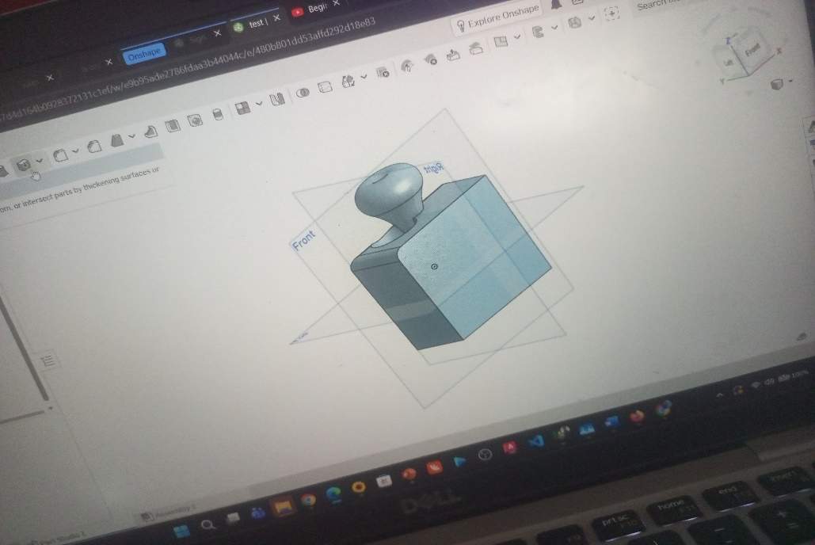
While the CAD fundamentals week had been conducted using desktop CAD software for introductory purposes, the organization's actual production design work was carried out almost entirely within Onshape, a fully cloud-based parametric CAD platform, and my later, more extended period of 3D modelling work was accordingly built around this platform specifically. My instructor explained the organization's rationale for standardizing on Onshape: unlike traditional desktop CAD packages, Onshape runs entirely within a web browser, storing all design data in the cloud rather than in local files, which greatly simplifies collaboration across the organization's design team, since multiple engineers can view, comment on, and even simultaneously edit the same document without the version-control complications, conflicting local file copies, manual file sharing, that traditional file-based CAD software is prone to. Onshape's built-in version history, which automatically and continuously records every change to a document, also meant that I could freely experiment with a design and revert to an earlier state if an approach did not work out, without needing to manually save numbered backup copies of a file, a habit I had been taught to rely on with desktop software and which Onshape's architecture rendered largely unnecessary.
Learning Onshape's specific interface and workflow conventions took a short period of adjustment even with the general CAD fundamentals I had established the week before, since although the underlying parametric modelling concepts, sketches, features, constraints, assemblies, transferred directly, Onshape's particular organization of documents into tabs, its handling of part studios versus assemblies as distinct but linked document elements, and its browser-based interface conventions all required some hands-on familiarization. I spent my first day back on CAD work simply rebuilding several of the exercise parts from the earlier fundamentals week within Onshape, a deliberately low-stakes way of mapping my existing knowledge onto the new platform's specific tools and menu structure before moving on to more consequential design work.

4.4 Applied 3D Modelling: Enclosures and Mounting Assemblies
Once comfortable navigating Onshape, I was assigned a series of increasingly substantial modelling tasks connected to the organization's ongoing hardware projects, the most significant of which involved designing enclosures and mounting brackets intended for outdoor or semi-outdoor electronic hardware, precisely the kind of enclosure that would, in later weeks, need to house the ESP32 and associated RS485 interface hardware for the GridWatch project. I began with a relatively simple enclosure design exercise, modelling a two-part clamshell enclosure sized to house a small printed circuit board and a handful of connectors, and in doing so learned to think carefully about design-for-manufacture considerations that had not been emphasized during the more academic fundamentals week: wall thickness sufficient for structural rigidity without excessive material usage, draft angles to ease removal from an injection mould or 3D-printed support structure, boss features for self-tapping screw bosses used to fasten the enclosure halves together, and cable entry points sized and positioned appropriately for the connectors and wiring the enclosure would need to accommodate.
A particularly instructive exercise involved designing a mounting bracket intended to secure a small electronics enclosure to an existing metal railing or frame, a task that required me to take physical measurements of the target railing using digital calipers, translate those measurements into a properly dimensioned sketch, and then iterate through several versions of the bracket design as my initial attempt proved, upon review with my instructor, to have insufficient clearance around one of the railing's mounting bolts. This iteration process, producing a first design, having it reviewed, identifying a practical flaw, and revising the model accordingly, was repeated across several of my design assignments during this period and gave me a much more grounded appreciation for the gap that often exists between a design that appears correct on screen and one that will actually fit and function correctly once fabricated and installed in its intended physical context.
I also gained experience working with sheet metal modelling techniques within Onshape, used for a bracket design intended to be fabricated from bent aluminium sheet rather than a solid or 3D-printed part, learning to define bend lines, bend radii, and K-factor parameters that govern how a flat sheet metal pattern unfolds into its final bent three-dimensional shape, and generating the corresponding flat pattern drawing needed to communicate the part's cutting and bending specifications to a fabricator. Toward the end of this period, I contributed to a small multi-part assembly representing an early concept enclosure for what would later become the GridWatch device housing, working from a rough set of dimensional requirements provided by the hardware team, sketching and modelling the main enclosure body, a mounting plate for the ESP32 development board, and a small ventilated panel intended to accommodate the RS485 transceiver module's wiring, and assembling these parts together using mates to confirm they fit as intended before the design was handed off for further refinement closer to the GridWatch build itself in Week Ten.

4.5 Challenges and Reflection
The most persistent challenge I encountered throughout this period of CAD work was developing the discipline of fully constraining every sketch before proceeding to build features upon it, a habit that, despite my instructor's early warnings, I did not fully internalize until I had personally experienced the frustration of an under-constrained sketch distorting unpredictably partway through a moderately complex part, requiring me to unpick and rebuild several dependent features as a result. A second, related challenge involved thinking in terms of a feature tree with dependencies, since modifying an early feature in a part with many subsequent dependent features could, and on at least one occasion did, cause later features to fail or behave unexpectedly, requiring a careful, methodical approach to feature ordering and, where necessary, restructuring a model's feature tree to make it more robust to anticipated future changes, a lesson with a clear parallel to the emphasis on modular, loosely coupled code structure I had absorbed during the earlier JavaScript portion of my training.
By the conclusion of this period, I had developed a genuine working competency in parametric 3D modelling using Onshape, capable of independently sketching, constraining, and modelling reasonably complex parts and assemblies, generating basic engineering drawings, and applying elementary design-for-manufacture principles to enclosure and bracket designs. More broadly, this chapter of my training reinforced a theme that had already begun to emerge from the preceding embedded systems week: that the specific tools and syntax of any given engineering discipline, whether a programming language or a CAD platform, are ultimately in service of a smaller set of underlying design disciplines, careful specification, iterative refinement in light of real-world constraints, and rigorous verification before committing to a final result, that transfer across domains far more readily than the superficial tools themselves might suggest.

CHAPTER FIVE
SOLAR ENERGY SYSTEMS: THEORY AND INSTALLATION PRACTICUM

5.1 Introduction to the Chapter
The sixth and eighth weeks of my industrial training were devoted to solar photovoltaic (PV) energy systems, the third of the organization's four principal areas of technical focus, and, alongside the embedded systems work of Chapter Three, the area most directly foundational to the GridWatch project that forms the centrepiece of this report. These two weeks divided naturally into a theoretical component, covering the fundamental principles of solar PV system design, sizing, and component selection, and a practical component, in which I took part directly in the installation, wiring, and commissioning of a residential solar PV system for a client in Abeokuta. Although separated on the calendar by an intervening week of CAD modelling, these two weeks are presented together in this chapter given their close thematic unity: the second week's hands-on installation work served, in effect, as the practical validation and application of the sizing and design principles established during the first.
This chapter carries particular significance for the report as a whole, since the physical solar installation described in its second half, a 2.5kVA hybrid inverter system with a 24V lead-acid battery bank and bifacial photovoltaic panels, is architecturally near-identical to the installation that the GridWatch project, documented in Chapter Six, was subsequently designed to monitor. My direct, hands-on familiarity with this class of system, gained during these two weeks, proved indispensable once I began designing GridWatch's firmware and communication architecture several weeks later, since I was, by that point, working from genuine physical memory of the hardware involved rather than from an abstract specification alone.

5.2 Fundamentals of Solar Photovoltaic Systems
My introduction to solar energy systems began with the underlying physics of the photovoltaic effect, the process by which semiconductor materials, typically silicon-based in commercial panels, generate a direct electric current when exposed to sunlight, as photons striking the material excite electrons across the semiconductor's junction and produce a flow of charge. My instructor for this week, a senior member of the organization's solar installation team, kept the physics discussion relatively brief given the practical 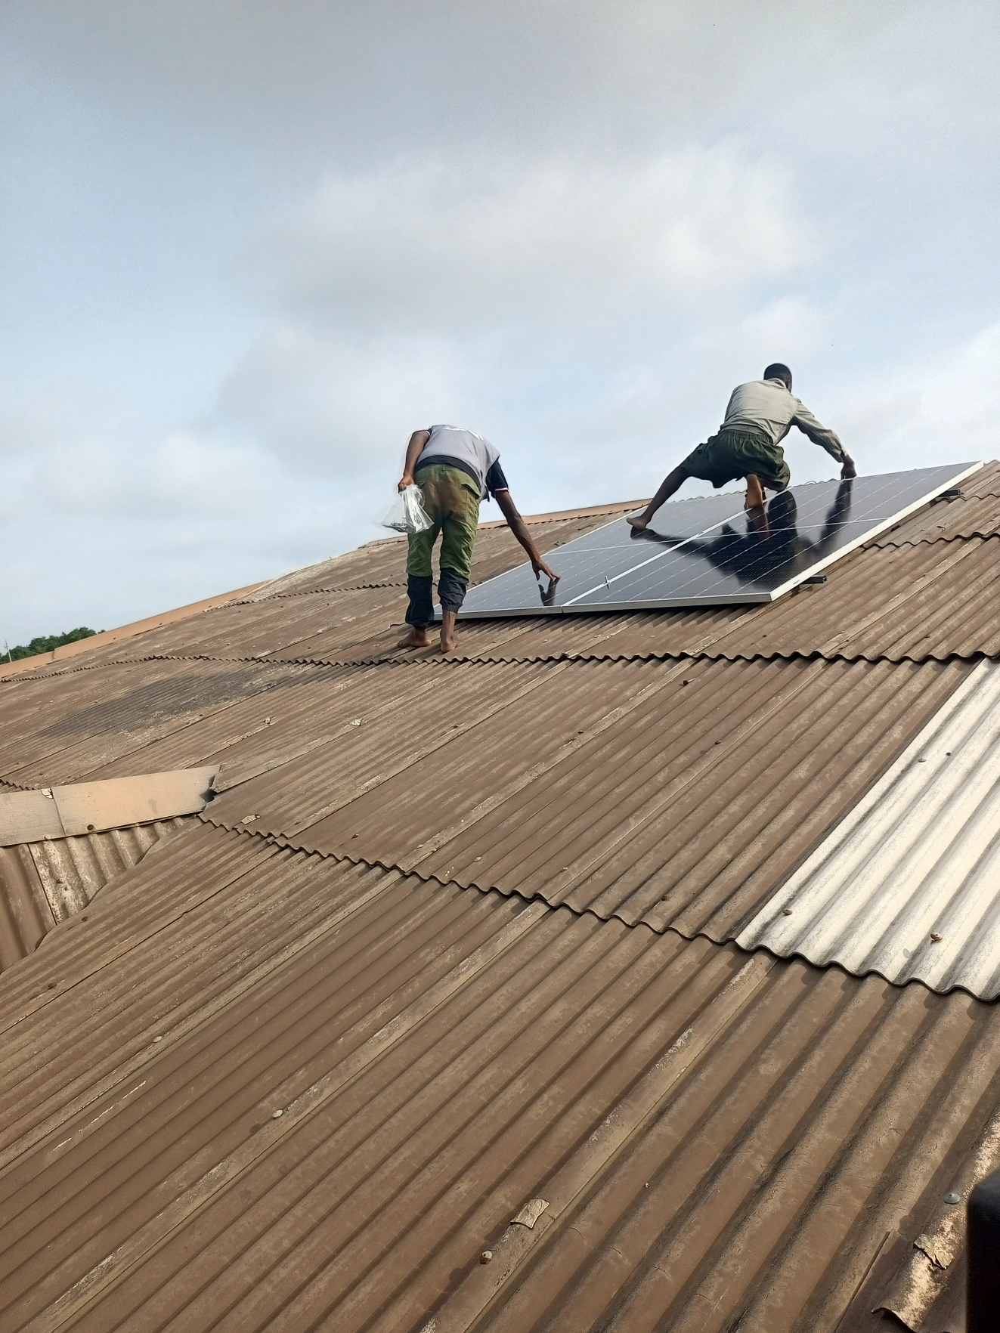orientation of the training, but ensured I understood the basic distinction between monocrystalline, polycrystalline, and the increasingly common bifacial panel technologies, the last of which, capable of generating power from sunlight striking both their front and rear surfaces, would feature directly in the installation I later helped carry out in Week Eight.
From this physical foundation, I moved to the electrical characteristics that govern how PV panels are specified and combined into arrays: open-circuit voltage, short-circuit current, and the maximum power point, the specific combination of voltage and current at which a panel delivers its greatest possible power output under a given set of illumination and temperature conditions, a point that shifts continuously throughout the day as irradiance and panel temperature change. This maximum power point concept led directly into a discussion of Maximum Power Point Tracking (MPPT) charge controllers, which I learned continuously adjust their electrical loading of the connected PV array in order to track this shifting optimal operating point in real time, in contrast to the simpler and less efficient Pulse Width Modulation (PWM) charge controllers that represent an older, lower-cost alternative technology. I also studied the electrical implications of wiring panels in series versus parallel configurations, series wiring increasing the combined string voltage while keeping current unchanged, and parallel wiring increasing combined current while keeping voltage unchanged, and worked through several paper exercises calculating the resulting voltage and current characteristics of hypothetical panel arrays under each wiring configuration, exercises that proved directly applicable when I came to understand the actual two-panel parallel configuration used in the Week Eight installation.
A substantial portion of this theoretical week was devoted to battery systems and system sizing calculations. I studied the characteristics of the tubular lead-acid battery technology commonly used in Nigerian residential and small commercial solar installations, including concepts of nominal voltage, amp-hour capacity, depth of discharge, and the practice of connecting multiple batteries in series to achieve a higher system voltage, typically 24V or 48V for the class of installation the organization most commonly undertook, as opposed to the lower 12V systems more common in smaller, single-battery setups. I worked through complete system sizing exercises, starting from an assumed daily household energy consumption figure expressed in kilowatt-hours, and working backward to determine an appropriately sized inverter capacity, an appropriately sized battery bank capable of supplying the required energy across a specified number of autonomy days without solar input, and a correspondingly sized PV array capable of both meeting daily consumption and recharging the battery bank within the available daylight hours, all while accounting for reasonable system losses due to inverter efficiency, wiring resistance, and battery charge and discharge efficiency. These sizing exercises, though conducted on paper using hypothetical scenarios during this theoretical week, mirrored closely the kind of sizing calculation that, as I later learned during the Week Eight practicum, had actually been performed for the real client installation I would go on to help install.
The week concluded with an overview of hybrid inverter technology, the class of inverter, exemplified by the 2.5kVA unit used in the Week Eight installation, capable of intelligently managing multiple power sources, solar PV, battery storage, and utility grid or generator supply, and automatically switching between them according to availability and a configured priority scheme, a considerably more sophisticated piece of equipment than the simple standalone inverters I had encountered in earlier, less formal exposure to solar technology. I also received a brief introduction to the Modbus communication protocol in the specific context of solar equipment, as my instructor noted that most modern MPPT charge controllers and hybrid inverters, including the SRNE-brand equipment the organization commonly installed, expose their operating parameters and live readings over an RS485 serial interface using the Modbus RTU protocol, a detail that, connecting directly back to the serial communication protocols I had studied during the embedded systems week, registered with me at the time as a potentially interesting point of technical overlap between the software, embedded, and solar strands of my training, though I did not yet know how directly this overlap would come to matter once the GridWatch project began.

5.3 Site Survey and Installation Planning
Two weeks later, following the intervening period of CAD modelling documented in Chapter Four, I returned to the solar team for a full week of hands-on installation work, joining two experienced technicians for the installation of a residential solar PV system for a client in Abeokuta. The week began with a site survey at the client's residence, during which I observed and assisted the lead technician in assessing the property's suitability for solar installation. Roof orientation was the first consideration, confirmed using a simple compass application to verify that the section of roof selected for the panel array faced close to true south, the orientation that maximizes solar irradiance capture at Abeokuta's latitude across the year, while the roof's pitch, structural condition, and the extent of shading from nearby trees and adjacent structures at different times of day were also assessed, since even partial shading on a single panel within a series-connected string can disproportionately reduce the output of an entire array.
With the array location settled, we assessed placement options for the battery bank and inverter, which needed to be housed indoors in a dry, ventilated space both to protect the equipment and to keep DC cable runs from the panels to the charge controller reasonably short, minimizing resistive voltage drop of the kind I had studied theoretically during the sizing exercises two weeks earlier. I measured the distance from the proposed panel location to the intended equipment room, and we sketched a cable route along the roof edge and down through an external wall conduit, noting the need for a lightning arrestor and proper earthing given the array's roof-mounted, and therefore lightning-exposed, position. I also observed the technician's interaction with the client during this survey, translating technical siting and capacity constraints into plain language and setting realistic expectations about what a 2.5kVA system could and could not power simultaneously, a client-facing dimension of engineering practice I had not previously considered and came to appreciate over the course of the week as being just as important to a successful installation as the technical work itself.

5.4 Mounting, Panel Installation, and Electrical Wiring
The middle days of the week were spent assembling the panel mounting structure and installing the array itself, using a pre-fabricated aluminium rail mounting system rather than a custom-welded frame, which the lead technician explained was now standard practice for residential rooftop installations owing to its speed of installation and its ability to accommodate slightly uneven roof surfaces. I assisted in installing roof hooks positioned directly over roof rafters, verified from inside the roof structure and cross-checked by careful exterior measurement, since a misplaced hook risks either an unsupported panel edge or a weakened, patched roof penetration, and each hook was sealed with a weatherproofing compound to prevent water ingress. Once the aluminium mounting rails were secured across the hooks and levelled at several points along their length, the two Longi bifacial 540W panels were lifted into position, a task requiring careful coordination given their size, weight, and the obvious hazard of manoeuvring a large, wind-catching surface at height, and secured using mid and end clamps torqued to the manufacturer's specification with a torque wrench, since both over- and under-tightening carry distinct risks to the panel frame and glass and to long-term mechanical security respectively.
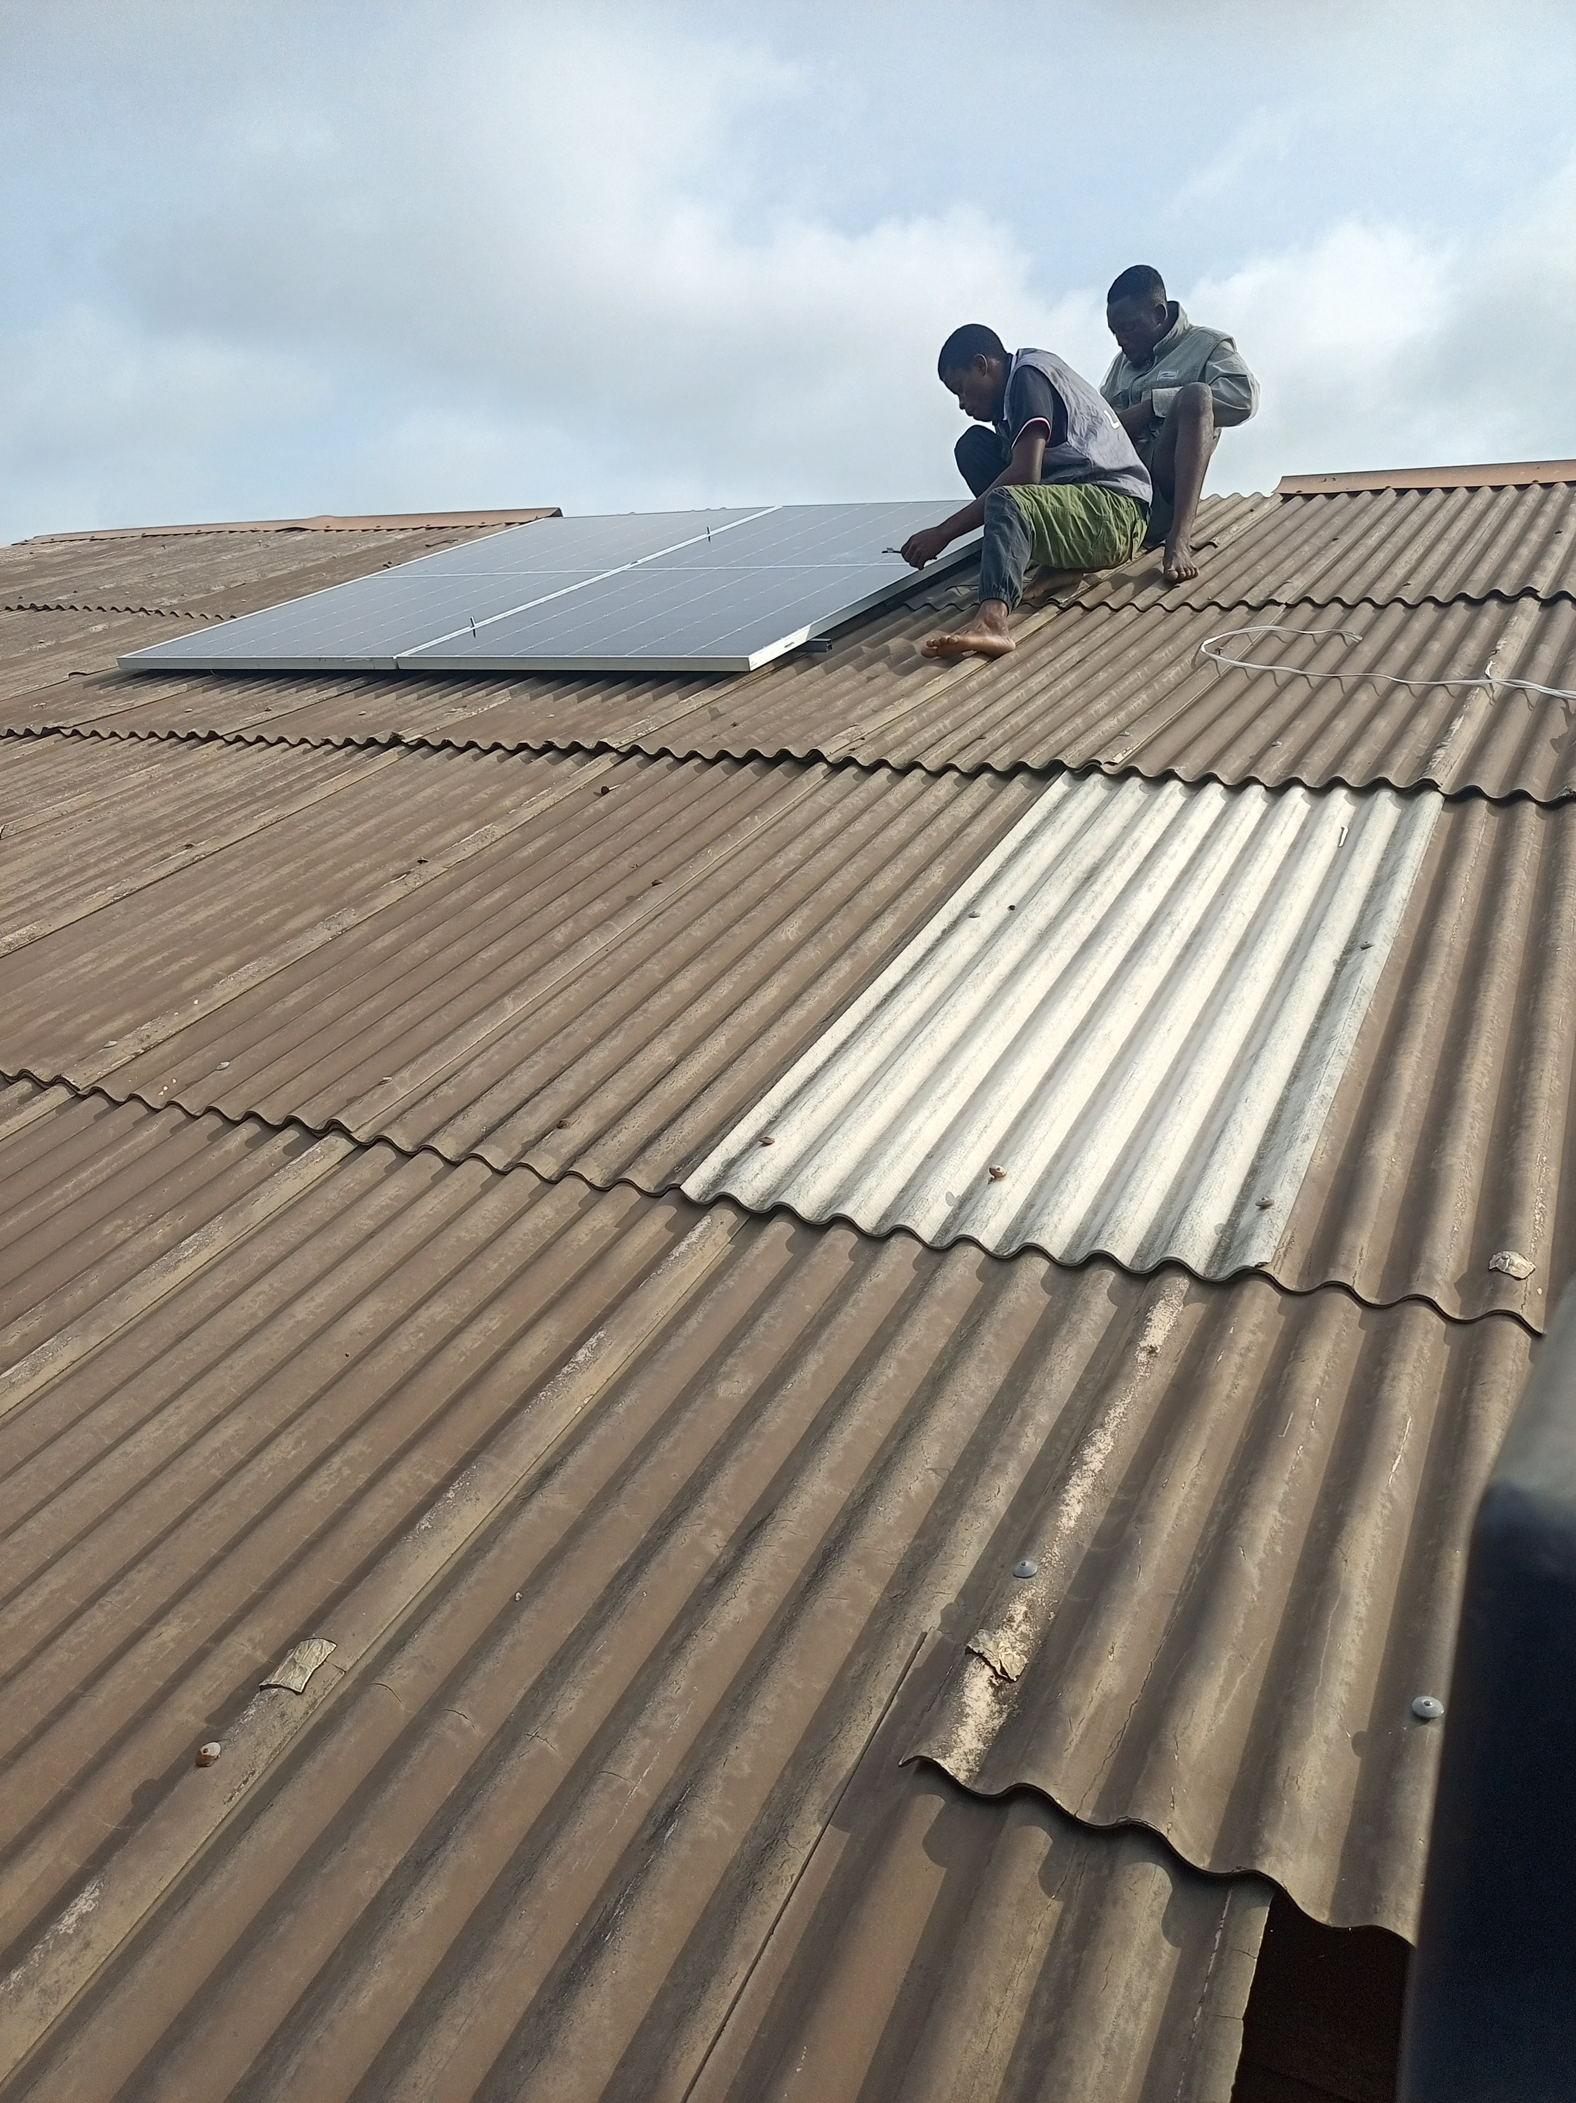
Plate 5.1: Securing the panel array to the rooftop mounting structure.

I learned that the bifacial panels used on this installation had been deliberately selected for their ability to capture reflected and diffused light on their rear surface in addition to direct sunlight on the front, an advantage that depends on mounting the panels with a small standoff gap above the roof surface to allow this rear-side gain to materialize, a consideration that had directly influenced the rail height selected during planning. I verified each panel's open-circuit voltage and short-circuit current individually using a digital multimeter before connecting them in parallel, a basic but important step that would catch any manufacturing defect or wiring fault before it was buried inside a sealed connector under live sun, and this parallel wiring configuration, chosen to match the array's output characteristics to the SRNE charge controller's input specifications, gave direct physical form to the series-versus-parallel wiring calculations I had performed on paper two weeks earlier.
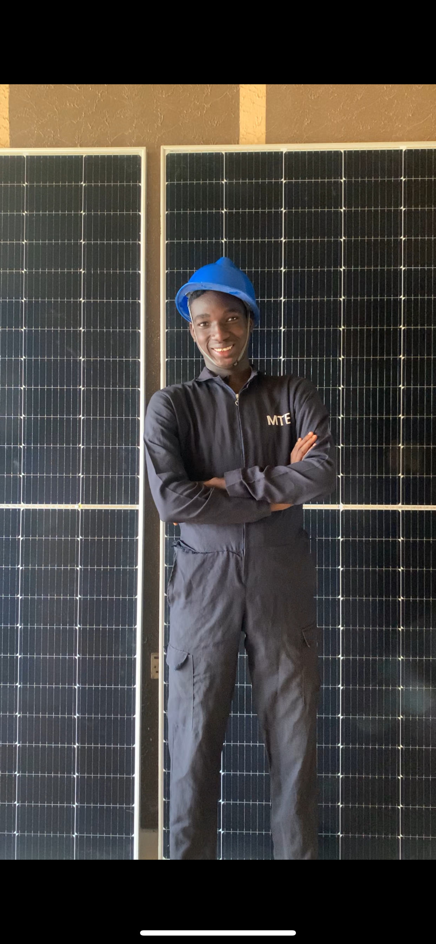
Plate 5.2: The author with the installed bifacial solar panel array.

With the panels mechanically installed, attention turned to the electrical wiring proper, beginning with routing UV-resistant, double-insulated DC cable from the array down to the equipment room via a sealed roof penetration and external conduit, secured at regular intervals with UV-stable cable ties to prevent chafing against the roof edge, a detail the lead technician was particular about given that chafed insulation on a live DC circuit carrying several amperes represents a genuine fire risk rather than a merely cosmetic concern. Inside the equipment room, I assisted with interconnecting the two tubular lead-acid batteries in series to form the 24V bank the inverter required, using appropriately rated battery cable and cable lugs crimped with a hydraulic crimping tool, torqued to specification, since loose battery terminals are a common cause of arcing and localized heating, a fire hazard as well as a silent source of energy loss. Appropriately rated DC fuses and circuit breakers were installed between the battery bank and charge controller and between the charge controller and panel array, sized to the maximum expected current with an appropriate safety margin, and a complete earthing system was installed for the array frame, mounting rails, and inverter chassis, tied to a dedicated earth rod whose resistance I verified using a clamp-on earth tester, a mandatory safety measure given both fault-current protection requirements and the real risk of induced surges from lightning strikes during Abeokuta's rainy season.

5.5 Charge Controller and Inverter Commissioning
With the mechanical and cabling work complete, the latter part of the week focused on configuring and commissioning the system's active electronic components: the SRNE Shiner 2460 MPPT charge controller and the 2.5kVA hybrid inverter. Having studied MPPT theory during the earlier solar fundamentals week, I was already familiar with the general principle by which the controller continuously adjusts its input impedance to track the array's maximum power point as irradiance and temperature vary, but seeing the Shiner 2460 physically wired and powered up for the first time made this theory considerably more concrete. We connected the battery bank to the controller before the panel array, following the sequence specified in the manufacturer's manual, and once the controller's front panel display illuminated and registered a stable battery voltage reading, we connected the array and watched incoming PV voltage and charging current register almost immediately, a genuinely satisfying moment after several days of preparatory work.
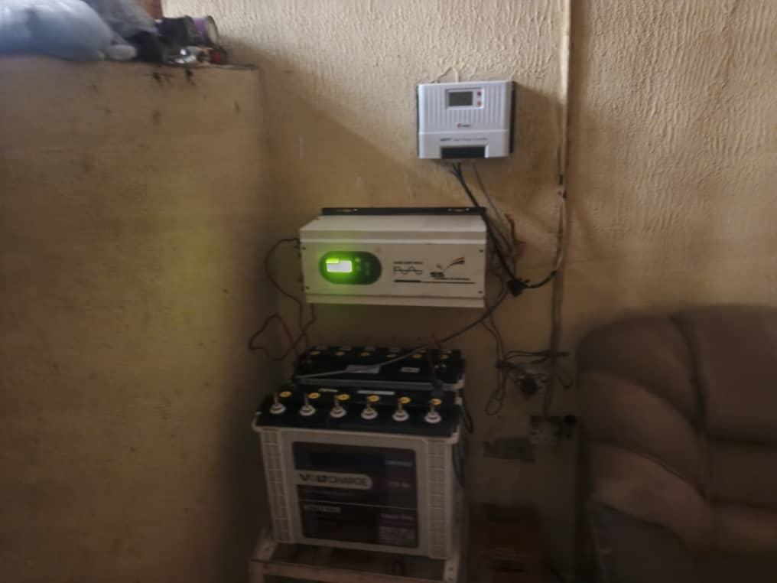
Plate 5.3: The commissioned charge controller, inverter, and battery bank.

Configuring the controller involved setting battery type, charging voltage thresholds, and load output parameters through its front panel menu, matched specifically to the tubular battery chemistry installed at this site rather than relying on generic default presets, since incorrect voltage thresholds can lead to chronic undercharging or, worse, overcharging and premature battery failure. I noted with particular interest that the Shiner 2460 exposed its operating parameters over an RS485 serial interface using the Modbus RTU protocol at a baud rate of 9600, the exact communication interface and protocol my solar fundamentals instructor had mentioned in passing two weeks earlier and that I would need to interface with programmatically when building the GridWatch firmware in Week Ten; at this stage, my interaction with this interface was limited to observing the lead technician briefly connect a laptop running the manufacturer's configuration software to confirm the applied parameters, though I made a point of asking questions about the register map and protocol out of a hunch, which later proved well founded, that this knowledge would matter later in the programme. The inverter was then connected to the battery bank and, once configured for the correct battery voltage and charging behaviour, wired to the client's household distribution board with an automatic changeover to grid or generator supply should battery state of charge fall below a configured threshold, behaviour we tested manually by simulating a loss of solar charging and confirming that connected household loads experienced no interruption during the source transition.
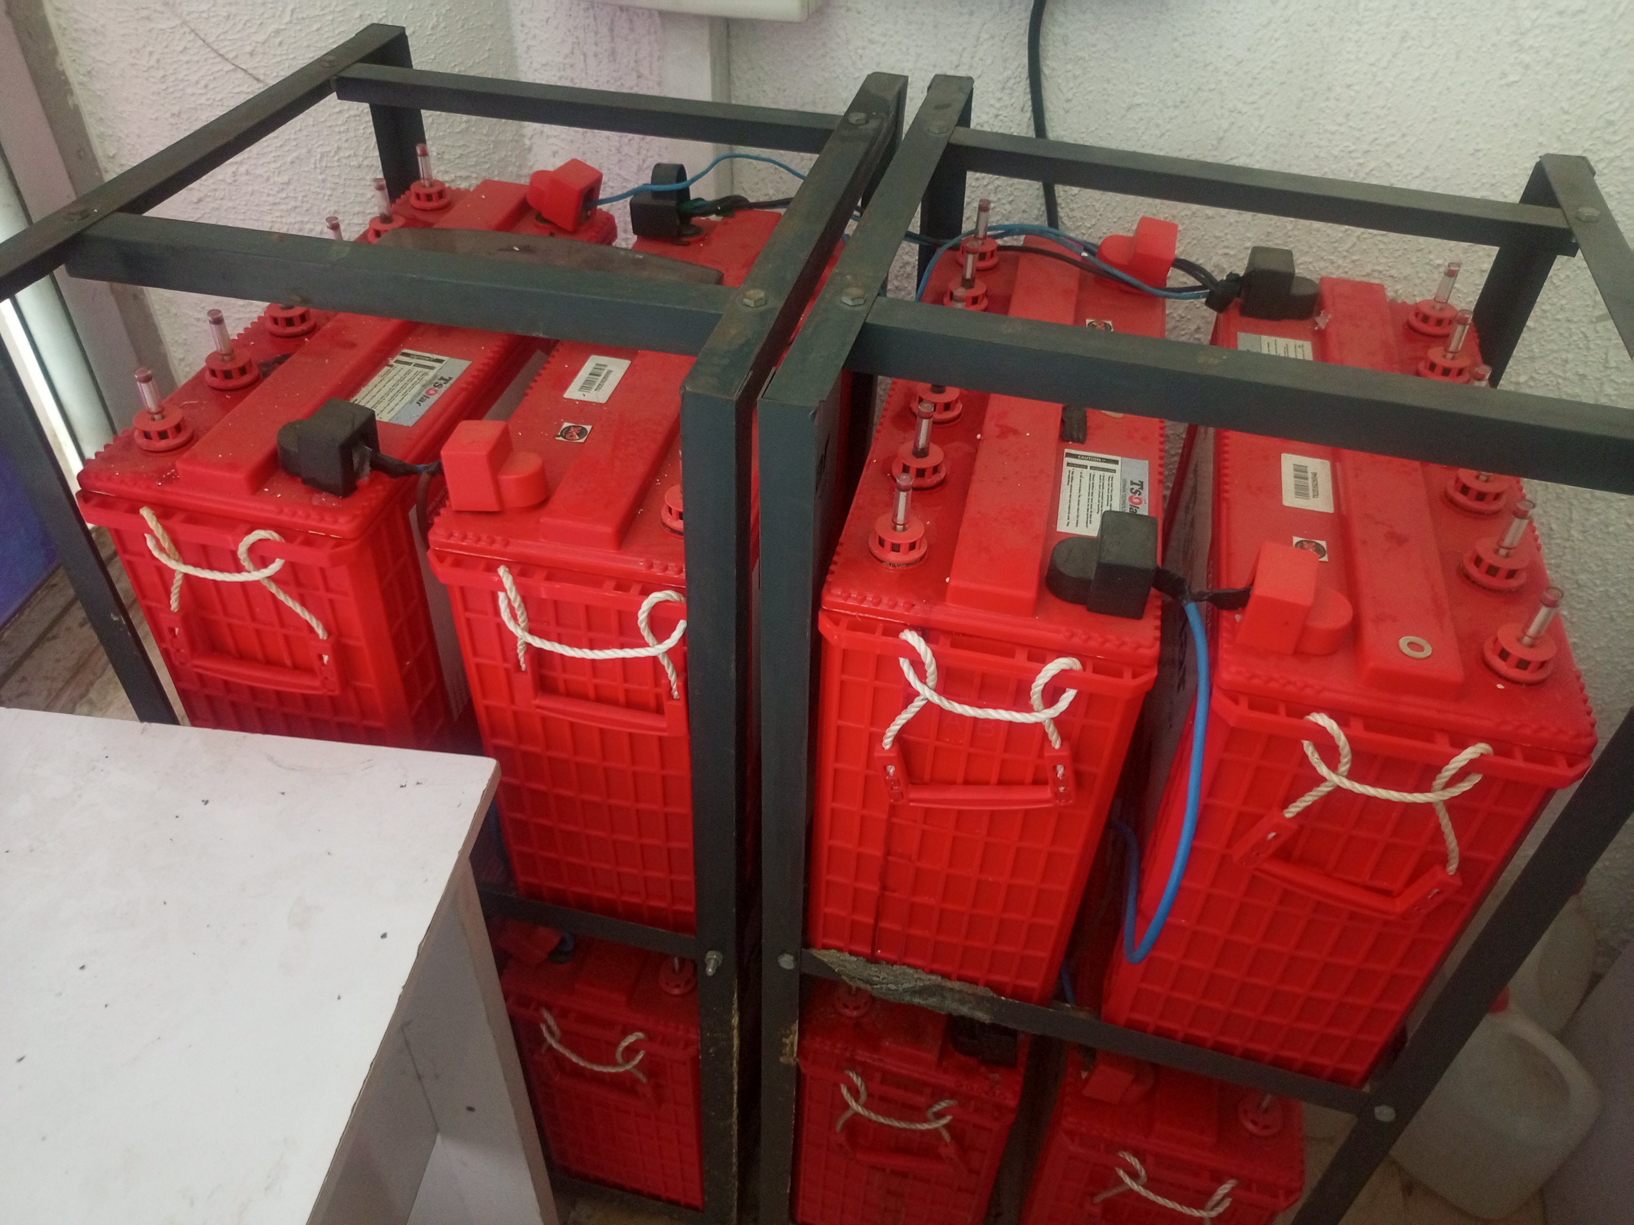
Plate 5.4: The tubular battery bank secured in its mounting frame.

5.6 System Testing, Challenges, and Handover
The final days of the installation were dedicated to comprehensive system testing before formal handover to the client. We tested the system under a range of load conditions, progressively connecting typical household appliances, lighting circuits, fans, and a refrigerator, while I used a clamp meter to monitor the inverter's output current and confirm the system could comfortably support the client's expected daily load profile without exceeding the 2.5kVA inverter rating, comparing my readings against the consumption figures the client had provided during the initial survey and finding good agreement, a validation of the sizing principles I had studied theoretically two weeks earlier. We also conducted a full charge-discharge cycle test on the battery bank, monitoring voltage and estimated state of charge at intervals overnight under a controlled load to confirm the battery bank's behaviour matched its rated specification, an exercise that gave me an early, informal preview of exactly the kind of continuous monitoring task that GridWatch would later be built to automate; sitting with a notebook and a torch checking battery voltage every few hours was effective but clearly unsustainable as a long-term monitoring strategy, an observation I discussed directly with one of the technicians, who agreed that a remote monitoring solution would be genuinely valuable to the organization's broader solar installation business.
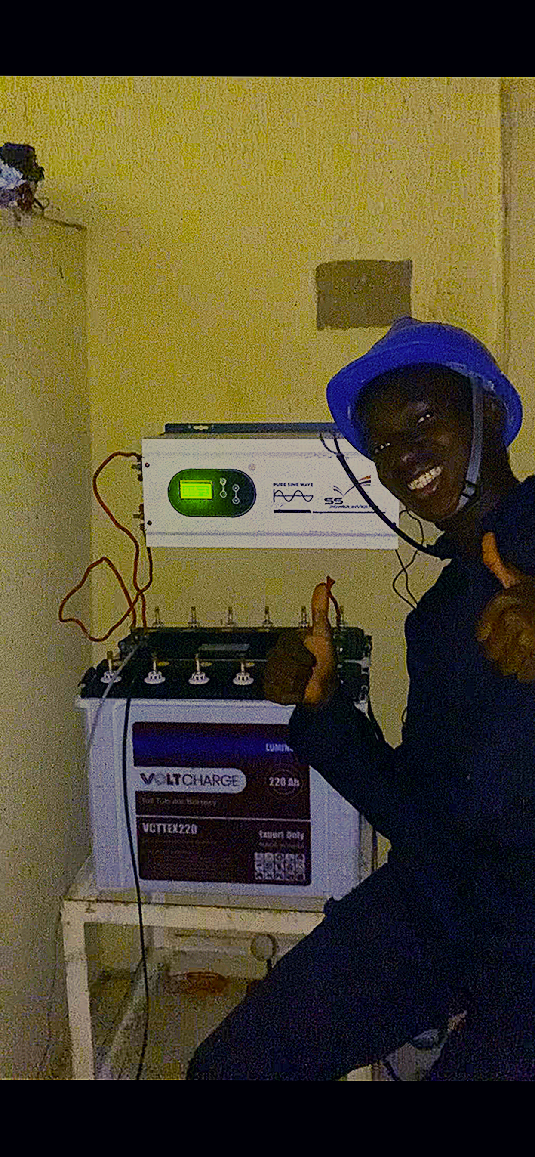
Plate 5.5: Confirming successful commissioning of the installed system.

A notable technical challenge arose during the initial power-up of the charge controller, when the unit failed to register the connected panel array despite correct wiring polarity and continuity confirmed independently with a multimeter; the lead technician traced the fault to a loose MC4 connector at a roof-level junction that had not been fully seated during earlier wiring, producing an intermittent open circuit that only manifested once the cable's own weight along the roof run placed slight physical stress on the joint. Resolving this required returning to the roof and inspecting every connector along the DC run by hand until the faulty connection was located and properly re-seated, an experience that taught me to verify, rather than merely assume, the mechanical integrity of every connector in a DC circuit. The week concluded with a formal client handover, during which the lead technician explained the inverter's front panel indicators and basic maintenance requirements, and I helped prepare a simple handover document summarizing the installed system's configuration and basic troubleshooting steps, an exercise in translating technical detail into a form a non-specialist client could reasonably understand and refer back to.

5.7 Reflection and Relevance to Subsequent Work
Taken together, these two weeks occupy a pivotal position in the overall arc of my SIWES training, since they were the weeks in which the abstract circuit diagrams and sizing calculations of solar system theory acquired physical weight, quite literally, in the form of panels I helped lift onto a roof and batteries I helped wire into a working bank. More significantly still, this chapter, more than perhaps any other single portion of my training, directly prepared me for the GridWatch project that occupied the final quarter of my attachment. My hands-on exposure to the SRNE Shiner 2460 controller, its RS485 Modbus interface, its multi-stage charging behaviour, and the physical topology of a 2.5kVA inverter system with a 24V battery bank and parallel-wired bifacial panels gave me a concrete mental model of the exact class of hardware I would later be asked to monitor remotely, meaning that when I began planning GridWatch's firmware and communication architecture in Week Nine, I was working from direct physical memory of a system I had helped bring to life rather than from an abstract specification alone. The overnight battery monitoring exercise, in particular, together with the technician's own observation about the value of remote monitoring, planted the motivating problem that GridWatch was ultimately designed to solve, making this chapter, in a real sense, the point at which the GridWatch project was conceived, even though its formal development would not begin for another week.

CHAPTER SIX
THE GRIDWATCH PROJECT

6.1 Introduction to the Chapter
The final three weeks of my industrial training, Weeks Nine, Ten, and Eleven, were devoted to a single, sustained project named GridWatch, an Internet of Things (IoT) monitoring and control system designed to provide remote visibility into the performance of a 2.5kVA solar inverter installation of the kind described in Chapter Five. GridWatch represented the culmination of my entire twelve-week attachment in a very literal sense: its firmware layer depended directly on the embedded C++ and serial communication skills established in Chapter Three; its hardware enclosure drew on the CAD and 3D modelling competencies developed in Chapter Four; its understanding of the underlying solar equipment it was designed to monitor rested on the theoretical and hands-on solar systems exposure documented in Chapter Five; and its backend, API, and dashboard layers were built almost entirely using the JavaScript, Node.js, and Express skills established in Chapter Two. If the preceding chapters of this report can be understood as documenting the individual instruments of an orchestra being tuned one at a time, this chapter documents the point at which they were finally played together.
This chapter presents the GridWatch project as a single coherent narrative organized by system layer and by the chronological order in which each layer was developed, rather than strictly by week, since, as with earlier chapters, the practical boundaries between the three weeks of GridWatch development were considerably more fluid than the training schedule implied; firmware work begun in Week Ten continued to be refined in Week Eleven even as backend and dashboard work began, and integration testing touching every layer of the system continued right through to the final days of the attachment, which are documented separately in Chapter Seven. The chapter begins with an account of the project's motivation and requirements, proceeds through the system's overall architecture, and then documents in turn the Node.js application groundwork laid in Week Nine, the ESP32 firmware and Modbus communication work of Week Ten, and the MQTT, backend, and dashboard development of Week Eleven, before closing with a discussion of the principal challenges encountered and a reflection on the project as a whole.

6.2 Project Motivation and Requirements
The motivation for GridWatch traced directly back to observations made during the Week Eight solar installation practicum documented in Chapter Five, during which I had personally taken part in an overnight battery monitoring exercise that involved manually checking voltage readings with a notebook and a torch at intervals through the night, a method that was effective for a one-off test but plainly unsustainable as an ongoing practice for a client who would need to monitor their system's health indefinitely after installation. This observation, shared and endorsed by one of the installation technicians at the time, had been noted informally, but it was only in Week Nine, once my rotation returned to the software side of the organization, that it was formally proposed to me as the basis for a capstone hardware project to occupy the remainder of my attachment.
My supervisor for this project, working with input from both the software engineering and solar installation teams, framed the requirements for GridWatch around a small number of core objectives. The system needed to continuously monitor the key operating parameters of a representative solar installation, specifically battery voltage, charging current, PV array voltage and current, and the charge controller's reported operating state, by communicating directly with the installation's existing SRNE Shiner 2460 MPPT charge controller over its native RS485 Modbus RTU interface, without requiring any additional sensors beyond what the controller already measured internally. This telemetry needed to be transmitted from the installation site to a cloud-based backend capable of storing a historical record of readings and exposing that data through both a REST API for on-demand queries and a real-time channel for live updates. Finally, the data needed to be presented through an accessible web-based dashboard that a non-technical client or the organization's own support staff could use to check system health at a glance, view historical trends, and receive some indication of abnormal conditions, all without needing physical access to the installation site.
I was given considerable latitude in choosing the specific technologies used to meet these requirements, subject to a few constraints reflecting the organization's existing technical preferences: the firmware would run on an ESP32, given its built-in WiFi connectivity and the embedded systems grounding I had already received in Week Four; the backend would be built in Node.js, consistent with the organization's existing software stack and my own training from Chapter Two; and, given that real hardware procurement for a dedicated RS485 interface module would take a number of days to arrive, I was encouraged to begin firmware development and testing using the Wokwi online circuit simulator, allowing software and communication logic to be developed and substantially de-risked before physical hardware was available, a practice my supervisor described as standard procedure for the organization's embedded projects generally.

6.3 System Architecture
Before writing any code, I spent the early part of Week Nine, in consultation with my supervisor, sketching out the overall system architecture that would guide the remainder of the project. The resulting design comprised four principal layers connected in a linear data pipeline. At the physical edge of the system, an ESP32 microcontroller would act as a Modbus RTU master, periodically polling the SRNE Shiner 2460 charge controller over an RS485 serial connection to read its holding and input registers. The ESP32 would then format the resulting readings as a JSON payload and publish them over WiFi to a cloud-hosted MQTT broker, specifically HiveMQ Cloud, using the lightweight MQTT publish-subscribe messaging protocol widely used in IoT applications for its low overhead and its suitability for devices with constrained bandwidth and intermittent connectivity. A Node.js backend service, subscribed to the relevant MQTT topic, would receive each incoming reading, persist it to a database for historical record-keeping, and make the data available to client applications through two parallel interfaces: a conventional REST API for historical queries and configuration actions, and a WebSocket server for pushing live readings to any connected dashboard in real time without requiring the client to continuously poll the API. Finally, a web-based dashboard, built as a separate front-end application, would consume both the REST API and the WebSocket stream to present the system's current status and historical trends to an end user.
I documented this architecture in a simple block diagram, which my supervisor reviewed and endorsed with only minor adjustments, principally a suggestion to deploy the backend and dashboard as separate, independently deployable services rather than as a single monolithic application, a suggestion that aligned with patterns I had studied in general terms during Week Three but had not yet applied to a genuinely deployed, internet-facing project. This decision meant that the backend would ultimately be deployed to Render, a cloud application hosting platform well suited to persistent Node.js services, while the dashboard, a largely static front-end application communicating with the backend over the network, would be deployed separately to Vercel, a platform optimized for exactly this kind of front-end deployment. This separation of concerns, an ESP32 edge device, a cloud message broker, an independently deployed backend, and an independently deployed dashboard, remained the guiding architecture for the remainder of the project and is reflected in the section structure of the remainder of this chapter.

6.4 Week Nine: Node.js Application Groundwork
With the architecture agreed, I spent the remainder of Week Nine building the foundational Node.js application layer that would later be extended into the full GridWatch backend, deliberately front-loading this work before hardware-specific firmware development began, since it allowed me to define and validate the data model and API surface the firmware would eventually need to conform to, using synthetic, manually generated test data standing in for real hardware telemetry. I initialized a new Node.js project, structured its source code into logically separated modules for routing, data models, and business logic, in keeping with the modular file organization principles I had first practised in Week Three, and set up the Express framework as the application's web server foundation.
I designed a preliminary REST API surface covering the core operations GridWatch would need: an endpoint for ingesting new sensor readings, endpoints for querying the most recent reading and for querying historical readings within a specified time range, and a basic endpoint for retrieving summary statistics such as minimum, maximum, and average battery voltage over a given period. I implemented these endpoints initially against a simple in-memory data store, deliberately deferring the choice and integration of a persistent database until the API's shape had stabilized, and wrote a small set of synthetic test readings, structured to match the fields I anticipated the SRNE controller would eventually provide, battery voltage, charging current, PV voltage, PV current, and a textual charging stage indicator, in order to exercise and validate each endpoint's behaviour before any real telemetry existed.
A significant portion of this week was also spent researching and prototyping the MQTT integration that would later connect the ESP32 firmware to this backend. I installed an MQTT client library for Node.js, and, using a temporary public MQTT broker for early testing purposes before the organization's HiveMQ Cloud account was provisioned, wrote a small standalone script that subscribed to a test topic and logged incoming messages to the console, and a companion script that published synthetic JSON payloads to the same topic at a fixed interval, simulating, in software alone, the message traffic the ESP32 firmware would eventually generate. This exercise allowed me to work out the MQTT topic naming convention the project would use, structured hierarchically by installation identifier and message type, and to validate that my backend's eventual MQTT subscriber logic, parsing an incoming JSON payload and routing it into the same data-ingestion logic used by the REST API's ingestion endpoint, worked correctly, all before a single line of firmware code had been written. By the end of Week Nine, I had a working, tested Node.js application capable of accepting sensor readings through either a REST endpoint or a simulated MQTT message, storing them in memory, and serving both current and historical queries back out through its API, providing a stable target for the firmware I would begin building the following week.

6.5 Week Ten: ESP32 Firmware and Modbus RTU Communication
Week Ten shifted my focus to the embedded side of the project, building the ESP32 firmware responsible for communicating with the SRNE Shiner 2460 charge controller and forwarding its readings to the cloud. Drawing directly on the serial communication protocol fundamentals established in Chapter Three, I began by researching the Modbus RTU protocol in detail, a protocol I had been introduced to only in passing during Weeks Four and Six but which I now needed to implement precisely. I learned that Modbus RTU is a request-response protocol in which a single master device, the ESP32 in this case, initiates every transaction by sending a request frame addressed to a specific slave device identified by a numeric address, with the slave, the charge controller, responding with the requested data or an error code, all communicated over the same RS485 physical layer and UART-based serial framing I had studied during the embedded systems week.
A necessary early step was obtaining and studying the SRNE Shiner 2460's Modbus register map from its technical documentation, a table specifying the numeric register addresses at which specific operating parameters, battery voltage, charging current, PV voltage, PV current, charging stage, and various status flags, could be read, along with the data type, scaling factor, and byte order used to encode each value. Translating this register map correctly into working firmware required careful attention, since a mismatched scaling factor or byte order would produce a value that appeared plausible at a glance while being subtly and misleadingly wrong, a class of error my supervisor specifically warned me to test for rigorously rather than simply accepting the first numerically reasonable-looking reading as correct.
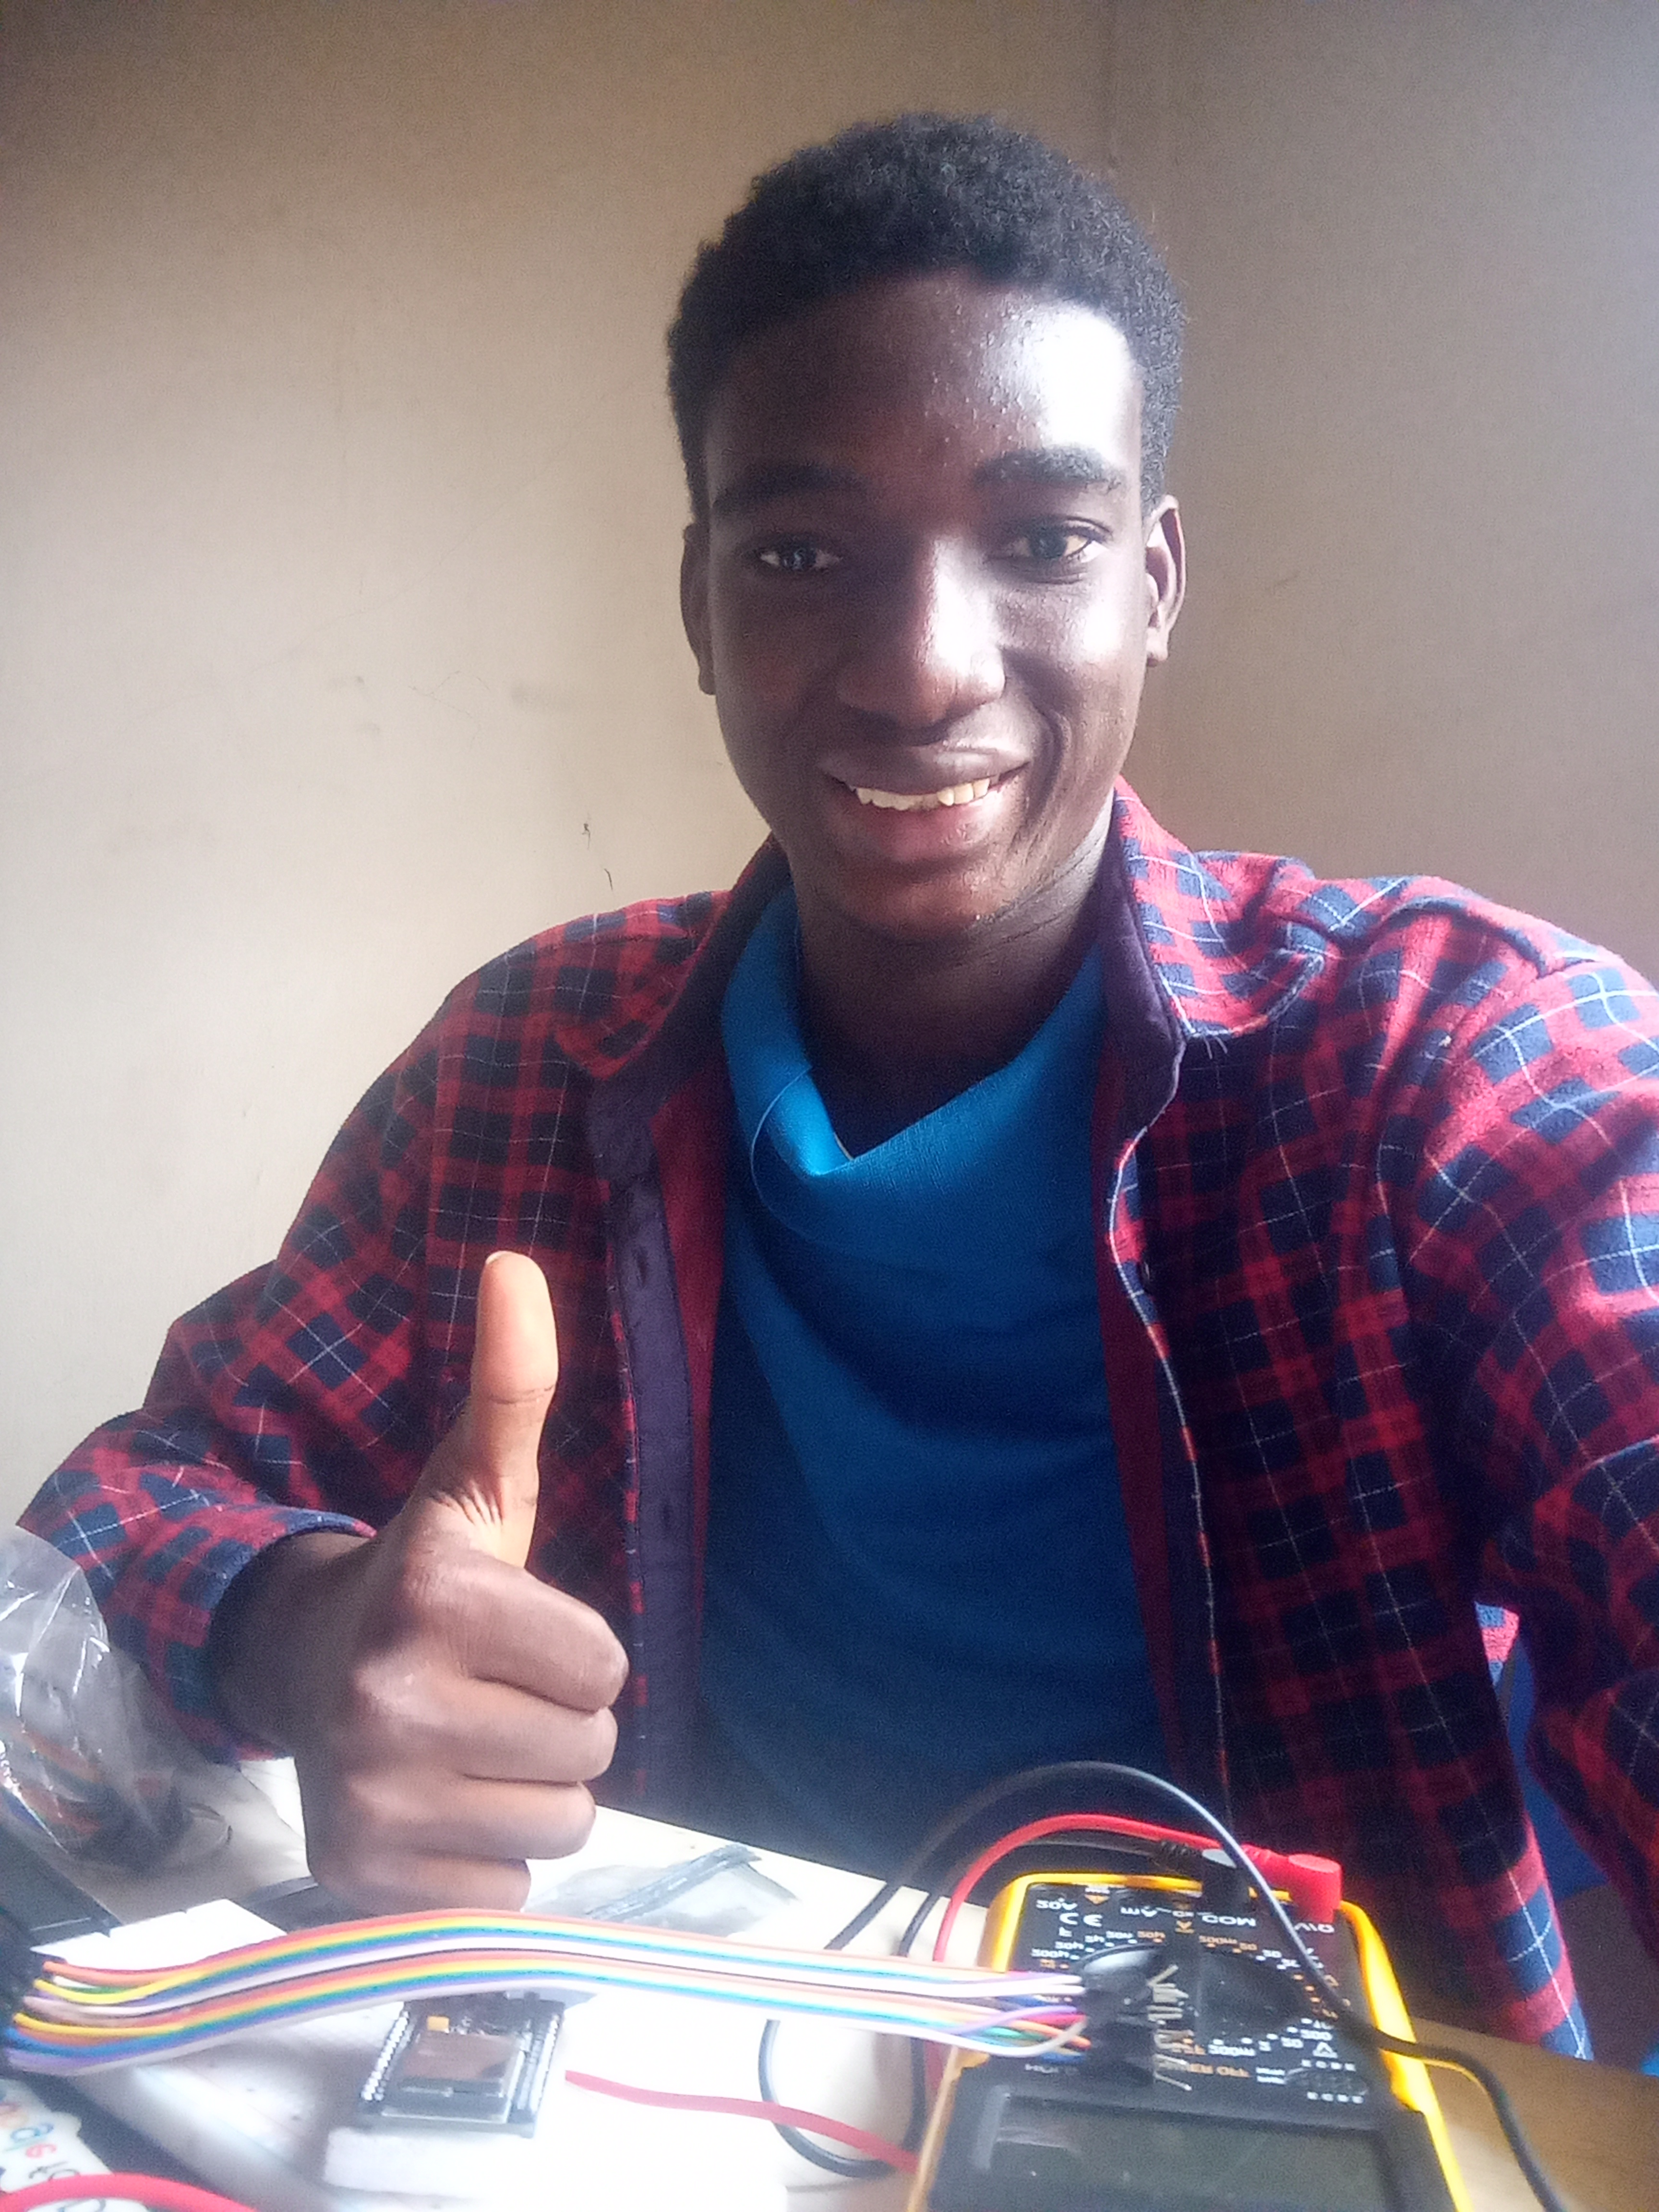
Plate 6.1: Verifying wiring continuity and signal levels during firmware bring-up.

Because the physical RS485-to-UART interface hardware needed to connect the ESP32 to the charge controller had not yet arrived from the supplier at the start of the week, I began firmware development entirely within the Wokwi online circuit simulator, a browser-based tool capable of simulating an ESP32 and a range of common peripherals with genuine code execution rather than mere visual mockup. Wokwi did not, naturally, provide a simulated SRNE charge controller directly, so I built what I termed a mock Modbus mode into the firmware from the outset, a configurable operating mode in which, rather than issuing real Modbus requests over a physical RS485 interface, the firmware generated plausible synthetic register values internally, following the same data structures and unit conversions that would apply to real hardware readings, and fed these synthetic values through the same downstream JSON formatting and MQTT publishing logic that would eventually handle real data. This approach allowed me to develop, and substantially debug, the entire firmware pipeline, register value formatting, JSON payload construction, WiFi connection management, and MQTT publishing logic, using the Wokwi simulator well before physical hardware was available, isolating the eventual hardware bring-up phase to validating the Modbus communication layer specifically rather than the entire firmware at once.
Once the RS485-to-UART interface module arrived later in the week, I wired it to the ESP32's hardware serial pins, connected it to the charge controller's RS485 terminals at the actual client installation site with my supervisor's assistance, and switched the firmware from its mock Modbus mode to genuine hardware communication, implementing the actual Modbus RTU request framing, including the CRC-16 checksum calculation Modbus RTU requires to detect corrupted frames, and parsing the corresponding response frames according to the register map I had studied earlier in the week. The first successful real reading, a plausible battery voltage value read directly from the live charge controller and printed to the serial monitor, was a genuinely significant moment in the project, confirming that the register map interpretation, byte order handling, and protocol framing I had built and tested entirely in simulation translated correctly to real hardware with only minor adjustments, principally a small timing delay I needed to introduce between consecutive Modbus requests to reliably avoid the controller responding with intermittent errors under back-to-back polling.
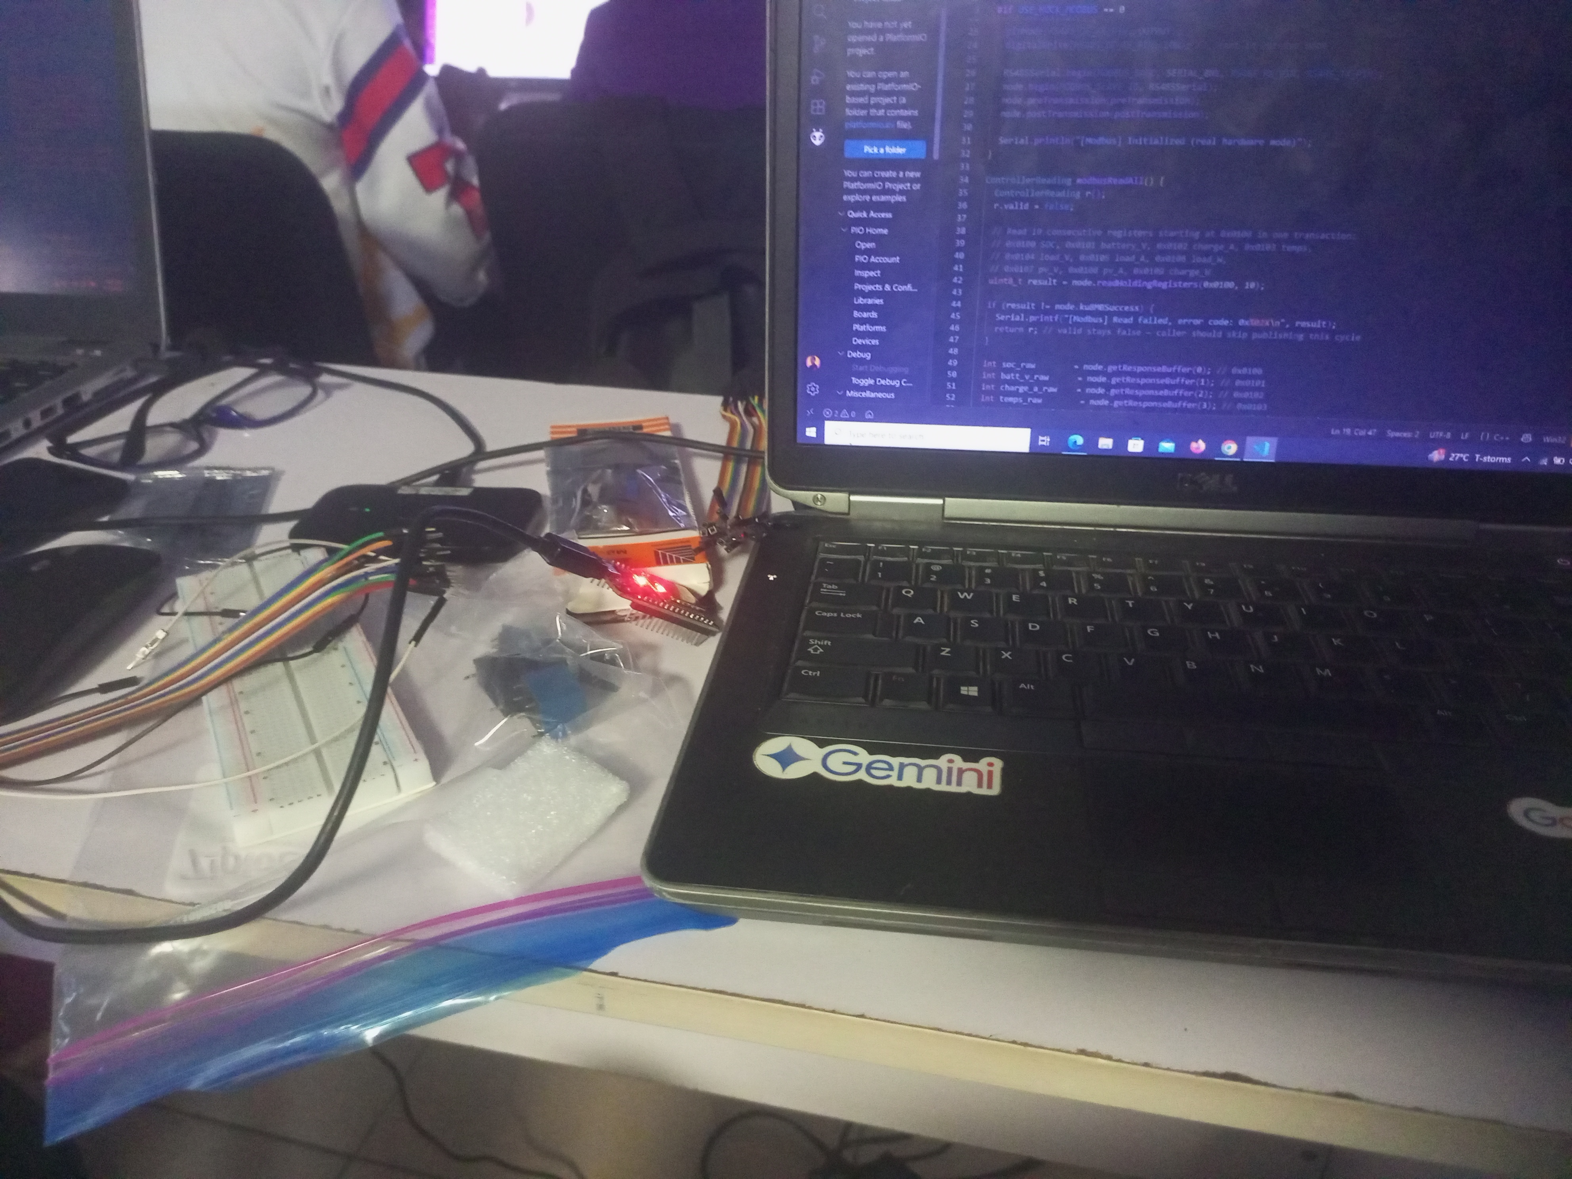
Plate 6.2: Developing and testing the ESP32 Modbus RTU firmware.

6.6 Week Eleven: Backend Integration, Cloud Connectivity, and the Web Dashboard
With working firmware capable of reading real data from the charge controller and publishing it over MQTT, Week Eleven was devoted to completing the cloud-facing backend, wiring it to genuine hardware telemetry rather than the synthetic data used during Week Nine's groundwork, and building the web-based dashboard through which the resulting data would ultimately be viewed. I began by provisioning the organization's HiveMQ Cloud MQTT broker account for production use, configuring appropriate access credentials for both the ESP32 firmware and the backend service, and updating both to connect to this genuine cloud broker rather than the temporary public broker used for early testing, verifying that messages published by the firmware, now running with real hardware attached at the installation site, were correctly received by my backend's MQTT subscriber logic, which I had already validated against synthetic messages the previous week.
A significant task for this week was integrating a persistent database to replace the in-memory data store used during Week Nine's prototyping, since an in-memory store would lose its entire history of readings every time the backend service restarted, an unacceptable limitation for a system intended to provide genuine historical monitoring. I designed a schema for storing individual sensor readings, each tagged with a timestamp and an installation identifier to support the possibility of the system eventually monitoring multiple installations rather than only the single pilot site, and updated my existing data-access logic to read and write against this persistent store rather than an in-memory array, taking care to preserve the same internal data-access interface my REST API and MQTT ingestion logic already depended on, so that this underlying storage change required no modification to the API layer itself, a direct practical benefit of the modular, loosely coupled code organization I had been encouraged to adopt as far back as Week Three.
I then deployed the completed backend service to Render, configuring the necessary environment variables for database connectivity and MQTT broker credentials, and worked through several rounds of deployment troubleshooting, principally around correctly configuring the platform's networking and environment configuration to allow the deployed service to maintain a persistent MQTT connection rather than the more typical short-lived request-response pattern a conventional REST API deployment might assume. With the backend successfully deployed and confirmed to be receiving and storing live readings from the field-deployed firmware, I turned to the web dashboard, generating its initial front-end code structure and then iterating on its layout and functionality to present current readings prominently, alongside historical charts of battery voltage and charging current over selectable time ranges, querying the backend's REST API for historical data and establishing a WebSocket connection to the backend for live updates to the current-reading display, so that a user viewing the dashboard would see new readings appear automatically as they arrived rather than needing to manually refresh the page.
The dashboard was deployed to Vercel, a platform well suited to hosting this kind of front-end application, and configured to communicate with the Render-hosted backend over the public internet, completing the full data pipeline from the physical charge controller at the client installation site through to a live, publicly accessible web dashboard. Seeing a battery voltage reading, generated moments earlier by real hardware physically wired to a real charge controller several kilometres away, appear automatically on a dashboard loaded in a browser on my laptop, without any manual intervention at any point in the pipeline, was among the most satisfying moments of my entire twelve-week attachment, and represented the point at which the individual layers of the system, each developed and tested largely in isolation over the preceding weeks, were finally confirmed to function correctly together as a whole.

6.7 Challenges Encountered During the GridWatch Project
The GridWatch project presented a number of challenges that, taken together, proved more demanding than any single earlier week of my training, precisely because the project required integrating competencies from every preceding chapter of this report rather than exercising any one of them in isolation. The most persistent technical challenge involved the Modbus RTU communication layer itself; even after the mock Modbus mode work in the Wokwi simulator had validated my understanding of the register map and payload formatting logic, the transition to real hardware surfaced timing-related issues that no simulation could have fully anticipated, specifically the need for a deliberate delay between consecutive Modbus requests to avoid intermittent response errors from the charge controller, a subtlety I resolved through careful, iterative testing directly against the live hardware, incrementally adjusting timing parameters and observing the resulting effect on response reliability over repeated polling cycles.
A second significant challenge involved managing WiFi connectivity reliability in the firmware, since the ESP32's WiFi connection to the installation site's network occasionally dropped, particularly during testing conducted at times of poor signal strength, and my initial firmware implementation had no graceful handling for this condition, simply failing to publish readings silently until the device was manually reset. I addressed this by implementing connection state monitoring and automatic reconnection logic within the firmware's main loop, along with a local buffering mechanism that queued a small number of readings in memory during a connectivity outage and flushed them to the MQTT broker once the connection was restored, ensuring that brief network interruptions did not result in silent, invisible gaps in the monitoring data reaching the dashboard.
A further class of challenge, less technical but no less real, involved the practical logistics of developing and testing a system with components physically distributed across a live client installation, my development laptop, and multiple cloud services; debugging an issue that might originate in the firmware, the MQTT broker, the backend, or the dashboard required a disciplined, systematic approach to isolating which layer of the pipeline was actually responsible for a given symptom, since a missing dashboard update could, in principle, stem from a firmware publishing failure, a broker connectivity issue, a backend subscription bug, or a front-end rendering error. I developed the habit of checking each layer's own logs and diagnostic output methodically, from the firmware's serial monitor output through the MQTT broker's own connection dashboard to the backend's server logs, before assuming the fault lay in any particular layer, a debugging discipline that proved to be one of the most broadly applicable professional skills I developed during the entire GridWatch project.

6.8 Reflection on the GridWatch Project
Reflecting on the three weeks documented in this chapter, GridWatch stands as the clearest single demonstration, within the whole of my SIWES attachment, of what genuinely cross-disciplinary Mechatronics engineering practice looks like in a real professional setting. No single preceding chapter of this report, taken alone, would have equipped me to build this system; it required the JavaScript and Node.js fluency of Chapter Two to build the backend and dashboard, the embedded C++ and serial protocol grounding of Chapter Three to build reliable firmware, the CAD competency of Chapter Four to design a physical enclosure for the hardware, and the direct, hands-on familiarity with solar installation hardware from Chapter Five to correctly interpret and communicate with the charge controller at the heart of the system. Beyond the specific technical deliverable, the project also gave me genuine, practical experience with the full lifecycle of a real IoT product, from initial requirements gathering and architectural design, through simulation-based development, hardware bring-up, cloud deployment, and finally end-to-end integration testing against a live installation, a lifecycle that no single classroom exercise or isolated training week could have taught me nearly as effectively as three weeks of sustained, connected work on a single real project.

CHAPTER SEVEN
INTEGRATION, TESTING, AND REPORT COMPILATION

7.1 Introduction to the Chapter
The twelfth and final week of my industrial training was structured differently from every week that preceded it. Rather than introducing new technical material, Week Twelve was devoted to consolidation: subjecting the completed GridWatch system to a more rigorous and systematic round of end-to-end testing than the incremental, layer-by-layer testing that had accompanied its development across Weeks Nine through Eleven, addressing the issues that this testing surfaced, and then turning to the compilation of this technical report itself, drawing together twelve weeks of software engineering, embedded systems, CAD, solar energy, and integrated project work into a single coherent document. This chapter documents both of these activities, the final integration and testing effort and the report-writing process, and closes the narrative account of my SIWES attachment before the concluding chapter presents a summary reflection on the training as a whole.

7.2 End-to-End System Integration Testing
Although each layer of the GridWatch system, the ESP32 firmware, the MQTT broker connection, the Node.js backend, and the web dashboard, had been tested individually and in adjacent pairs as it was developed across the three preceding weeks, Week Twelve began with a deliberate effort to test the system as a complete, unbroken pipeline under conditions closer to genuine, unattended field operation than any of my earlier testing had attempted. I arranged, with my supervisor's approval, to leave the firmware running continuously against the live charge controller at the client installation site for an extended, multi-day period, polling and publishing readings at its normal operating interval without manual intervention, while I monitored the resulting data arriving at the backend and dashboard remotely from the organization's office, checking in at intervals throughout each day rather than actively supervising the system continuously.
This extended soak test surfaced several issues that had not been apparent during the shorter, more actively supervised testing sessions of the preceding weeks. Most notably, I observed a small number of gaps in the recorded data corresponding to brief WiFi outages at the installation site, which the reconnection and local buffering logic I had implemented in Week Ten's firmware handled largely as intended, though I identified and fixed a minor bug in the buffer-flushing logic that occasionally caused a single buffered reading to be duplicated in the backend's database following a reconnection, an issue traced to an off-by-one error in the buffer's read pointer that had not manifested during my earlier, shorter test runs simply because they had not included enough reconnection events to expose it. I also noticed, over the multi-day period, a slow but noticeable upward drift in the ESP32's memory usage, which I diagnosed, with some assistance from my supervisor, as a memory allocation within my JSON payload construction logic that was not being properly released after each publish cycle, a subtle memory leak of exactly the kind I had been warned to guard against during the pointer and dynamic memory discussion in Chapter Three's C++ fundamentals instruction, and one that had simply not run for long enough during earlier testing to produce a noticeable effect before this extended soak test.
Beyond these firmware-level issues, this final testing period also surfaced a small number of front-end refinements to the dashboard, including a case where the historical chart component failed to handle a data query spanning a period with no recorded readings gracefully, displaying a confusing empty chart rather than a clear message indicating that no data was available for the selected range, an edge case that had simply not arisen during earlier development and testing, when the system's entire operating history was too short for such a gap to occur. I also conducted a basic review of the system's error handling and resilience more generally during this week, deliberately disconnecting the ESP32's power briefly to confirm it resumed normal operation correctly on restart, and briefly interrupting the backend's database connectivity to confirm the API responded with an appropriate error status rather than crashing outright, both tests that had not been part of my earlier, more feature-focused testing but that felt appropriate to perform before considering the system genuinely complete.
Having identified and resolved these issues, I conducted a final, shorter confirmation test to verify that the fixes were effective, again running the firmware continuously against the live installation for a further period and confirming, through direct inspection of the backend's stored data and the dashboard's live view, that the previously observed duplication and memory drift issues no longer occurred and that the dashboard correctly handled a subsequent test query against an empty data range. This final round of fixes and confirmation testing marked, in a practical sense, the point at which I considered the GridWatch project functionally complete and ready to be handed over to the organization for any continued operation or further development beyond the end of my attachment.

7.3 Documentation and Handover
Alongside this final testing effort, I spent a portion of Week Twelve preparing technical documentation for the GridWatch system intended for the organization's internal use beyond the conclusion of my SIWES attachment, since a system that only I personally understood would provide little lasting value to the organization once my placement ended. This documentation covered the firmware's configuration options, including how to switch between the mock Modbus testing mode and genuine hardware communication, the backend's environment variable configuration and deployment process on Render, and a brief overview of the dashboard's codebase structure for any future developer who might need to extend it. I also prepared a short, non-technical summary of the system's capabilities intended for the solar installation team specifically, describing in plain language what the dashboard could show a client and how the underlying hardware needed to be installed and connected at a new site, extending the kind of technical-to-plain-language translation work I had first observed during the Week Eight client handover documented in Chapter Five to this final, more substantial documentation task.

7.4 Report Compilation
The remainder of Week Twelve was devoted to compiling this technical report, a task that, while not itself a technical engineering exercise in the same sense as the preceding eleven weeks, nonetheless demanded its own kind of discipline and rigour. I approached the report by first reviewing the personal notes, code repositories, and photographs I had kept throughout the attachment, organizing them chapter by chapter according to the thematic structure ultimately adopted for this report, before drafting each chapter's content in turn, working to render what had, in practice, often been a somewhat non-linear and iterative learning process into a clear, coherent, and appropriately sequenced written narrative. I found this exercise valuable in its own right, since articulating in writing precisely what I had learned and why particular technical decisions had been made throughout the attachment often required me to clarify my own understanding of certain topics more precisely than had been strictly necessary while actually carrying out the work in real time.
This final week accordingly closed the twelve-week arc of my SIWES attachment on a note quite different from its beginning: where Week One had been about absorbing entirely new material as quickly as possible, Week Twelve was about consolidation, verification, and reflection, ensuring that the system built over the preceding eleven weeks was genuinely robust and well documented, and that the record of the attachment as a whole, in the form of this report, accurately and usefully captured what had been learned.

CHAPTER EIGHT
CONCLUSION

8.1 Summary of Skills and Knowledge Gained
The twelve weeks documented in this report provided an unusually broad cross-section of practical engineering exposure, spanning software engineering, embedded systems, computer-aided design, and renewable energy systems, unified in their final weeks by a single integrated hardware and software project. In software engineering, I progressed from foundational JavaScript syntax to genuine competency in building and deploying RESTful backend services using Node.js and Express, and gained direct, practical experience with asynchronous programming, a paradigm I now consider fundamental to any serious JavaScript development. In embedded systems, I developed a working fluency in C++ for resource-constrained microcontroller platforms, including GPIO control and the UART, I2C, and SPI serial communication protocols, culminating in the ability to implement the Modbus RTU protocol from its technical specification directly into working, field-tested firmware. In computer-aided design, I acquired a genuine parametric modelling competency using Onshape, capable of independently designing enclosures, brackets, and multi-part assemblies with appropriate attention to manufacturability. In renewable energy systems, I gained both the theoretical grounding to size and specify a solar PV installation and the direct, hands-on experience of physically installing, wiring, and commissioning one. Finally, and perhaps most significantly, the GridWatch project gave me practical, end-to-end experience with the complete lifecycle of a real IoT product, from requirements gathering and architectural design through simulation-based development, hardware bring-up, cloud deployment, and rigorous integration testing.
Beyond these specific technical competencies, I also developed a set of less tangible but equally valuable professional skills over the course of the attachment: a disciplined, systematic approach to debugging complex, multi-layered systems by isolating which component of a pipeline is actually responsible for an observed symptom rather than guessing; an appreciation for the importance of clear technical documentation and plain-language communication with non-technical stakeholders, observed repeatedly during client-facing solar installation work and practised directly during the GridWatch handover documentation; and a general confidence in approaching an unfamiliar technical domain, whether a new programming language, a new hardware protocol, or a new CAD platform, by breaking it down methodically into fundamentals before attempting more complex, applied work, a pattern that recurred across every chapter of this report.

8.2 Challenges Encountered
The attachment was not without its difficulties, and I consider an honest account of these difficulties to be as valuable a part of this report as the account of my successes. The most consistently demanding aspect of the training was the sheer breadth of technical material covered within a relatively short twelve-week period, requiring repeated, sometimes uncomfortable shifts in mental model, from JavaScript's dynamic, garbage-collected runtime to C++'s statically typed, manually managed environment, and from screen-based software work to the physically demanding, safety-critical discipline of rooftop solar installation. Each of these transitions required a period of deliberate recalibration before I felt genuinely competent in the new domain, and I do not believe this discomfort could have been entirely avoided given the training's explicit goal of providing broad, cross-disciplinary exposure within a fixed timeframe.
More specific technical challenges are documented in detail within their respective chapters of this report: the under-constrained sketch and feature-tree dependency issues encountered during CAD modelling in Chapter Four, the loose MC4 connector fault diagnosed during the solar installation practicum in Chapter Five, and the Modbus timing, WiFi reliability, and memory management issues encountered during the development and final testing of the GridWatch project in Chapters Six and Seven. Considered together, these challenges shared a common thread: nearly all of them stemmed from the gap between a design or implementation that appeared correct in principle, or in simulation, and its actual behaviour once exposed to the full complexity of a real, physical, or production environment, a gap that I came to recognize as one of the defining and recurring lessons of practical engineering work, distinct from the more controlled, idealized problem sets typically encountered in a university classroom setting.

8.3 Recommendations
Based on my experience over the course of this attachment, I offer the following recommendations to the relevant parties. To the Department of Mechatronics Engineering at FUNAAB and to the university's SIWES coordinating unit, I recommend continued and, where possible, strengthened emphasis on securing industrial placements that offer genuinely cross-disciplinary exposure of the kind documented in this report, since the opportunity to work across software, embedded systems, mechanical design, and energy systems within a single attachment provided a considerably richer training experience than a placement confined to any single one of these domains would likely have offered, and more closely mirrors the integrative nature of Mechatronics engineering practice itself.
To the host organization, I recommend continued investment in structured, mentor-guided onboarding of the kind I received at the start of each new technical area during this attachment, since the deliberate pairing of a dedicated mentor with each new phase of training was, in my own experience, one of the most effective aspects of the programme, and I would encourage the organization to consider formalizing this mentorship structure, along with the progressive, foundations-before-application training sequence used throughout my attachment, as a standard template for future students. I would also recommend that the organization consider extending the kind of extended, unattended soak testing conducted during Week Twelve of the GridWatch project earlier into the development process for future hardware projects, since several of the more subtle issues identified during this final testing phase, the firmware memory leak in particular, might have been caught earlier, and with less schedule pressure, had similar extended testing been introduced incrementally throughout development rather than concentrated primarily at the end.
To future SIWES students, particularly those in Mechatronics Engineering or related disciplines, I recommend approaching each new technical domain encountered during an industrial attachment with deliberate patience during its foundational stages, resisting the temptation to rush toward applied, project-based work before core concepts are genuinely well understood, since, as this report has documented repeatedly, the foundational weeks of instruction in each technical area, JavaScript fundamentals, C++ and embedded basics, CAD sketching discipline, and solar system sizing theory, proved directly and repeatedly essential to the more advanced, integrated project work that followed. I would also strongly encourage future students to maintain detailed working notes and documentation throughout their attachment, including for work that appears at the time to be merely a minor exercise, since several of the most valuable connections I was able to draw in compiling this report, such as the direct line between Week Four's I2C register-based communication exercises and Week Ten's Modbus RTU firmware, only became fully apparent in hindsight, and would have been considerably harder to reconstruct accurately without the notes and code I had kept from earlier in the programme.

8.4 Concluding Remarks
The twelve-week Students Industrial Work Experience Scheme attachment documented in this report provided a comprehensive, demanding, and ultimately deeply rewarding complement to the theoretical foundation established through my coursework in Mechatronics Engineering at the Federal University of Agriculture, Abeokuta. Beginning with foundational software engineering instruction in JavaScript and progressing through embedded systems programming, computer-aided design, and solar energy systems, the attachment culminated in the GridWatch project, an integrated Internet of Things monitoring system that drew directly and substantially upon every preceding phase of the training, and that stands, in my own assessment, as genuine evidence of the kind of cross-disciplinary technical synthesis that defines Mechatronics engineering as a field. I leave this attachment with a considerably expanded technical skill set, a more mature and disciplined approach to engineering problem solving, and a clearer sense of the kind of integrated, hands-on engineering work I hope to pursue over the remainder of my academic and professional career. I am grateful to the host organization, to my supervisors and mentors throughout the attachment, and to the SIWES scheme itself for making this experience possible.

